Supplementary Material
APPENDIX A
The Gibbs free energy change of a chemical reaction as a function of temperature
1. Why $G^{o}$(T ) = A+ BT +CT lnT ?
For a chemical reaction at a constant atmospheric pressure
Reactant 1 + Reactant 2 + ••• + Reactant i = Product 1 + Product 2 + ••• + Product j
The term $G^{o}$ (T ) defines the Gibbs free energy change in increase at temperature T if the
reaction proceeds completely. It can be calculated by
$∆G^{o}=\sum{n_{i}}\overline{G_{i}}-\sum{n_{j}}\overline{G_{j}}$ (Equation 1)
Products Reactants

$\overline{G_{i}}=μ_{i} and \overline{G_{j}}=μ_{j}$(Equation 2)

Where Gibbs free energy per mole for a component i is equal to its chemical potential μi, and $∆G^{o}$ equals to the sum of Gibbs free energy of all products j minus the sum of Gibbs free energy of all reactants i. If $∆G^{o}$<0, the chemical reaction can proceed spontaneously; If $∆G^{o}$=0, the chemical reaction is at equilibrium; if $∆G^{o}$>0, the chemical reaction can only proceed with external energy inputs. At temperature T, the Gibbs free energy of a species can be expressed by its definition G = H – TS [84].

$\overline{G_{T}}=\overline{H_{T}} -T\overline{S_{T}}$ (Equation 3)

Where the enthalpy term is calculated through $\overline{H_{T}}=\overline{H_{298K}}+\int_{298K}^{T}{C_{p}}dT$ and the entropy term is calculated through $\overline{S_{T}}=\overline{S_{298K}}+\int_{298K}^{T}{\frac{C_{p}}{T}}dT$[1]. Since the specific heat Cp (at constant pressure) does not vary too much with respect to temperature T [85], it is assumed to be constant in the present work, as in case of most of the literature [86]. Equation 3 can be therefore written as
$$\overline{G_{T}}=\overline{H_{298K}}+C_{p}\left(T-298\right)-T\overline{{(S}_{298K }}C_{p}(lnT-ln298))$$
$\overline{G_{T}}$= a +bT + cT ln T (Equation 4)
Where a, b and c are numerical coefficients. Equation 4 is also termed the Gibbs free energy of a species compared to a stable element reference state (SER) [87]. Combining Equation 1 and Equation 4, the term $∆G^{o}$(T ) can be finally expressed by
$∆G^{o}$(T ) = A+ BT +CT lnT (Equation 5)
The original expression for Gibbs free energy of a species as a function of temperature (which is derived by statistical thermodynamics) [86] is given in terms of an infinite series as
$\overline{G_{T}}$= a +bT + cT lnT + dT² + eT³ + f /T +… (Equation 5)
Usually only the first two or three terms are needed, as used by many researchers to calculate
phase diagrams (in particular CALPHAD) [86, 88]. The use of first three terms is already enough to give a near perfect (suggested by R-square value) fit for the Gibbs free energy data quoted from NIST [89].

2. How to get A, B and C?
The first step is to obtain the Gibbs free energy values for each species using the NIST
thermochemical table [6]. Values for species at different temperatures are summarized in Table 3, 4, and 5. The second step is to calculate $∆G^{o}$at each temperature T using Equation 1. The third step is to plot the 11 pairs of dots (T, $∆G^{o}$) and fit the dots to Equation 5. An example is shown in Figure 10, where the Gibbs free energy function of the reaction
4Cu + O₂ $→$2Cu₂O is obtained using such method. The quality of fitting is also assessed using residual analysis.
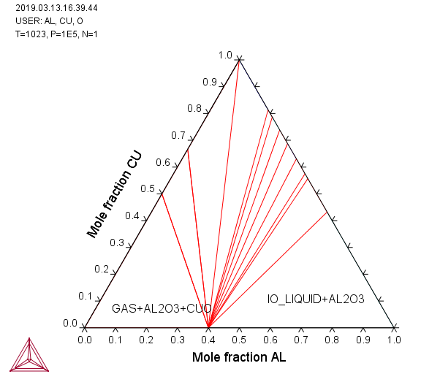
Fig. 1 Ternary phase diagram of Al-Cu-O₂ at 750⁰C showing isothermal sections

