SUPPORTING INFORMATION

Molecular Determinants of Complex Formation between DNA and the AT-rich Interaction Domain of BAF250a
Aditi Maulik^{1,$}, Malyasree Giri^{1,$} and Mahavir Singh^{1,2,*}
¹Molecular Biophysics Unit, Indian Institute of Science, Bengaluru, 560012
²NMR Research Centre, Indian Institute of Science, Bengaluru, 560012
$ These authors contributed equally to this work.
* singh@iisc.ac.in; Tel.: 91 80 2293 2839; Fax.: 91 80 2360 0535

This article contains figure S1-S5

Figure S1. Overlay of ¹⁵N-¹H HSQC spectra of ARID (968-1143) and ARID (968-1143) in complex with 20bp dsDNA (Dri-20).
Figure S2. NMR characterization of BAF250a ARID (1000-1119). (A) Assigned 2D ¹⁵N-¹H HSQC Spectrum of ARID (1000-1119). (B) Plot of ¹⁵N-¹H heteronuclear-NOE values vs. residues for BAF250a ARID (1000-1119).
Figure S3. Interaction of BAF250a ARID with dsDNAs monitored using isothermal titration calorimetry experiments. Raw and fitted ITC isotherms for BAF250a ARID/Dri-20 DNA interaction (A) and BAF250a ARID/P270-22 DNA interaction (B). The calculated K_{d}s are mentioned in the figure.
Figure S4. Four representative HADDOCK models from different clusters showing the possible mode of BAF250a ARID – DNA complex. A) HADDOCK models of BAF250a ARID/Mrf2-15 DNA complex. B) HADDOCK models of BAF250a ARID/Dri-15 DNA complex.
Figure S5. Published structures of ARID/DNA complexes. A) Mrf2 ARID/DNA complex (PDB ID: 2OEH). 2) Dri ARID/DNA complex (PDB ID: 1KQQ). The side chains of residues that were known to interact with DNA in the reported structures are shown in stick model.

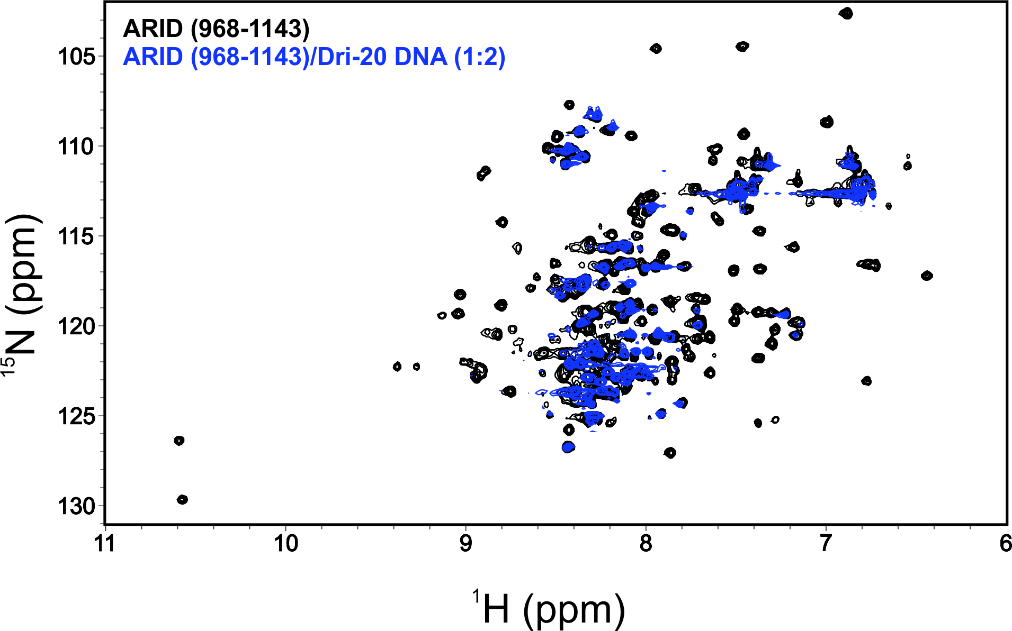
Figure S1. Overlay of ¹⁵N-¹H HSQC spectra of ARID (968-1143) and ARID (968-1143) in complex with 20bp dsDNA (Dri-20).

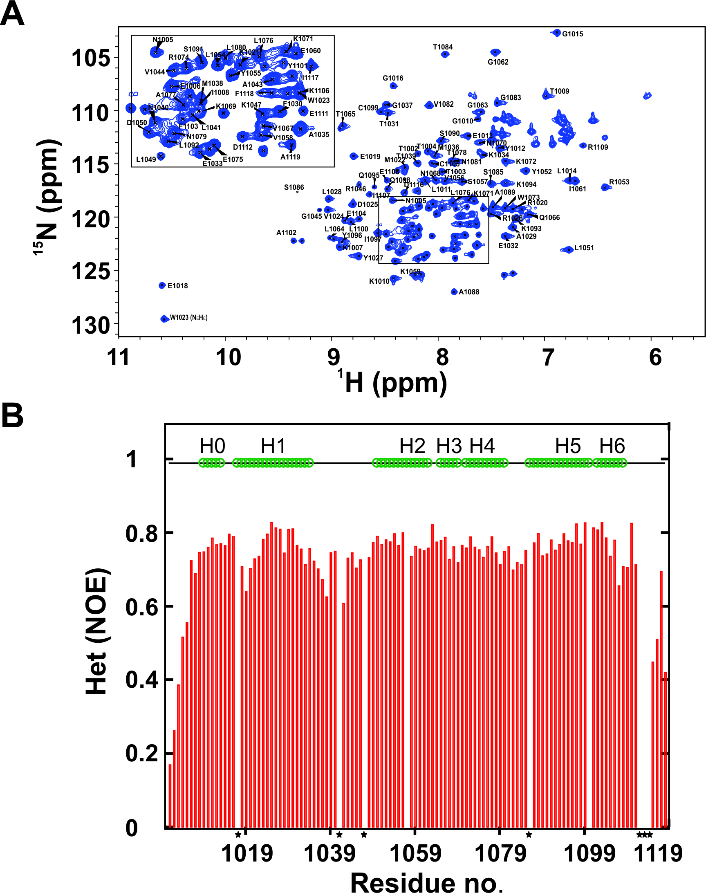

Figure S2. NMR characterization of BAF250a ARID (1000-1119). (A) Assigned 2D ¹⁵N-¹H HSQC Spectrum of ARID (1000-1119). (B) Plot of ¹⁵N-¹H heteronuclear-NOE values vs. residues for BAF250a ARID (1000-1119)
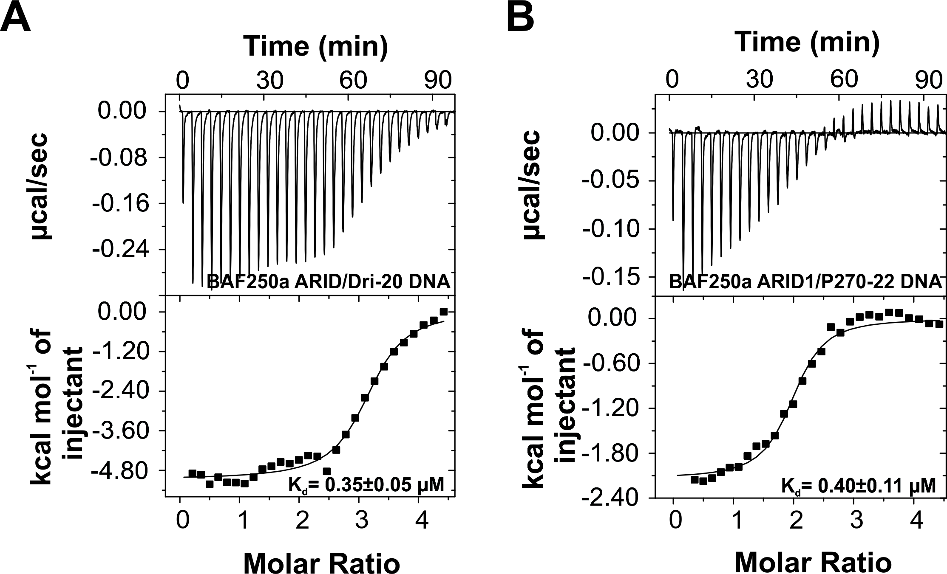

Figure S3. Interaction of BAF250a ARID with dsDNAs monitored using isothermal titration calorimetry experiments. Raw and fitted ITC isotherms for BAF250a ARID/Dri-20 DNA interaction (A) and BAF250a ARID/P270-22 DNA interaction (B). The calculated K_{d}s are mentioned in the figure.

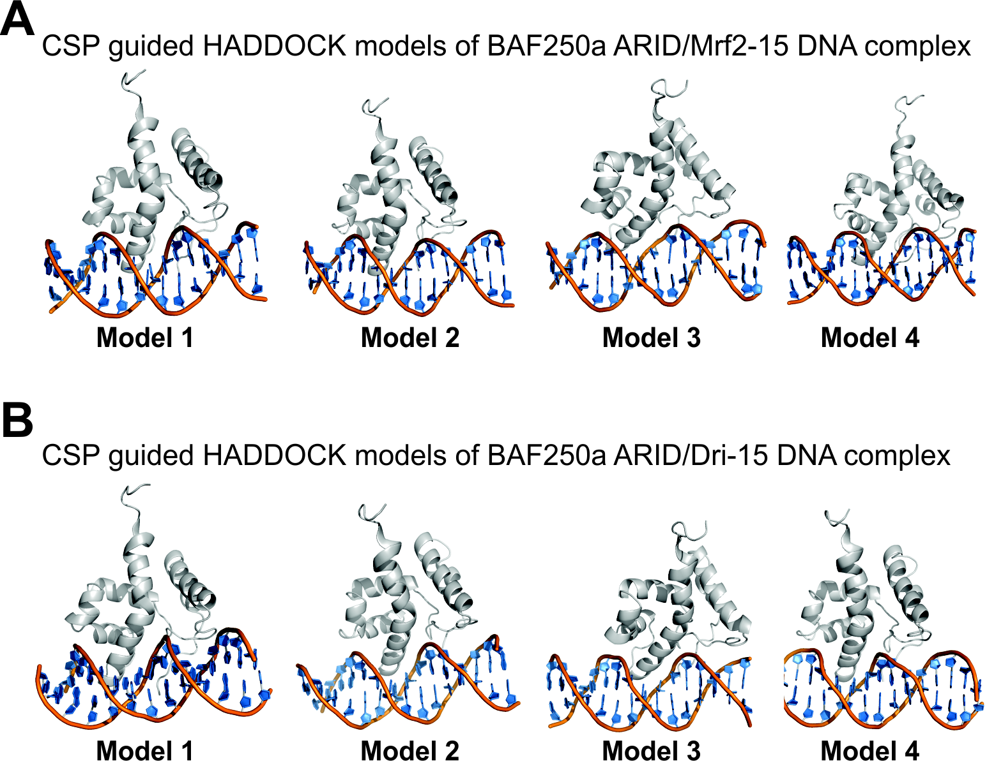

Figure S4. Four representative HADDOCK models from different clusters showing the possible mode of BAF250a ARID – DNA complex. A) HADDOCK models of BAF250a ARID/Mrf2-15 DNA complex. B) HADDOCK models of BAF250a ARID/Dri-15 DNA complex.

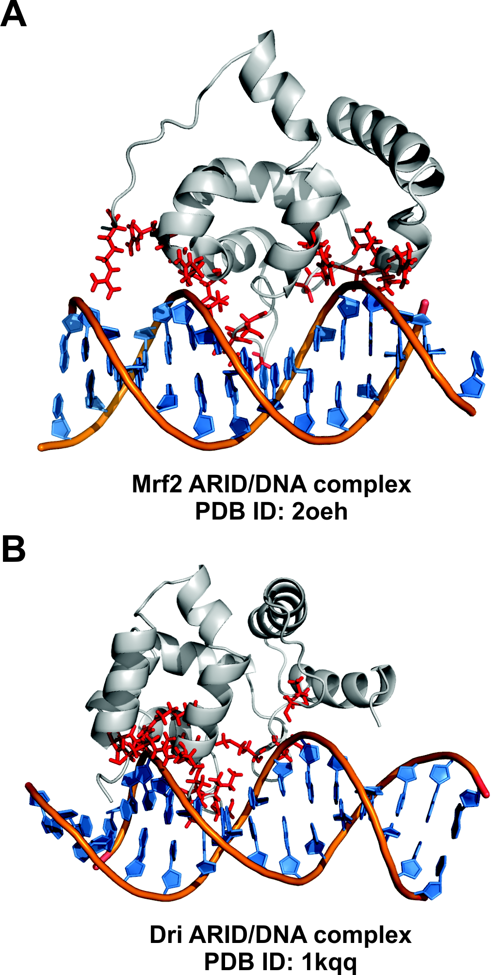

Figure S5. Published structures of ARID/DNA complexes. A) Mrf2 ARID/DNA complex (PDB ID: 2OEH). 2) Dri ARID/DNA complex (PDB ID: 1KQQ). The side chains of residues that were known to interact with DNA in the reported structures are shown in stick model.

