**Fig.1: FTIR spectra of the drug, pure polymers and compact formulation.**

**Figure: FTIR spectrum of Pamidronate disodium**



**Figure: FTIR spectrum of Thiolated chitosan**



**Figure: FTIR spectrum of HPMC- K4M**



**Figure: FTIR spectra of pamidronate disodium+ thiolated chitosan+HPMC-4KM**

**Fig. 2: DSC thermogram of the drug, pure polymers and polymeric film formulations.**

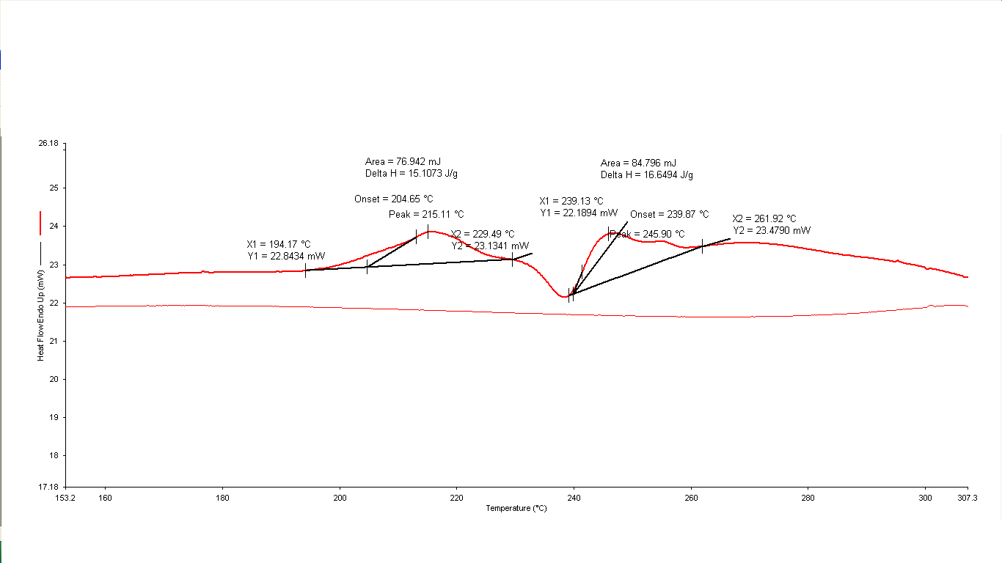

**Figure: DSC curve of pamidronate disodium**

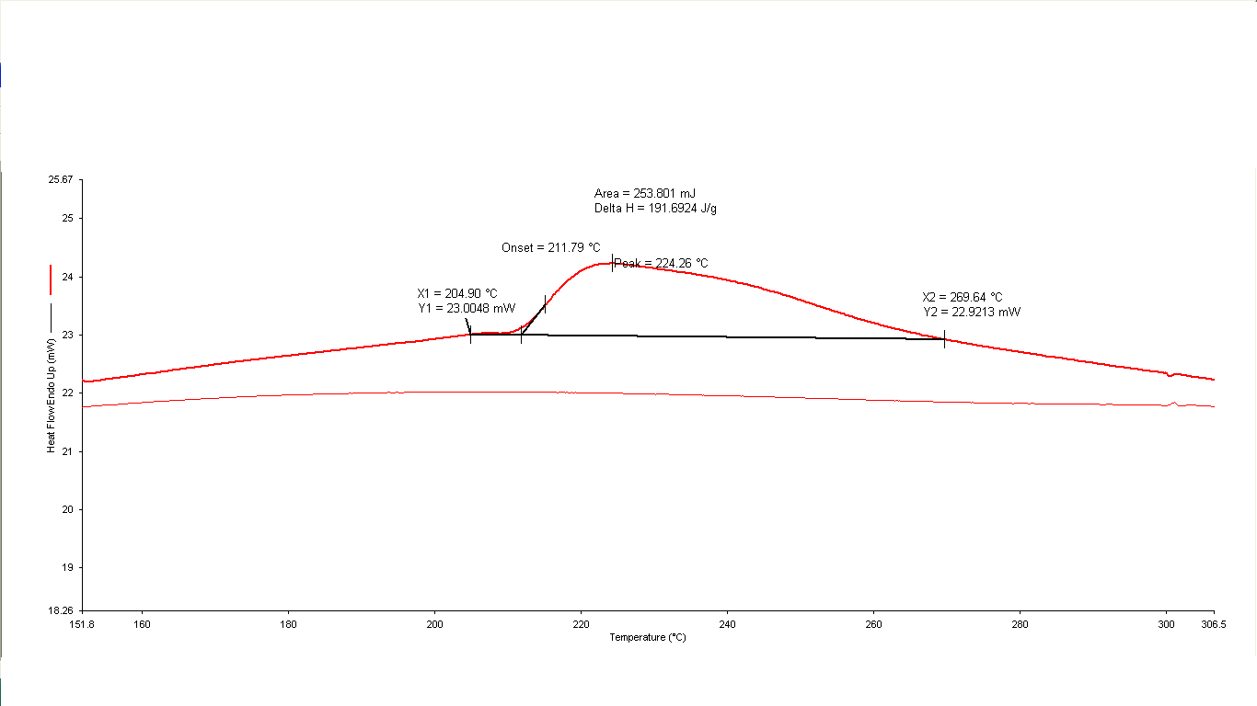

**Figure: DSC curve of thiolated chitosan**

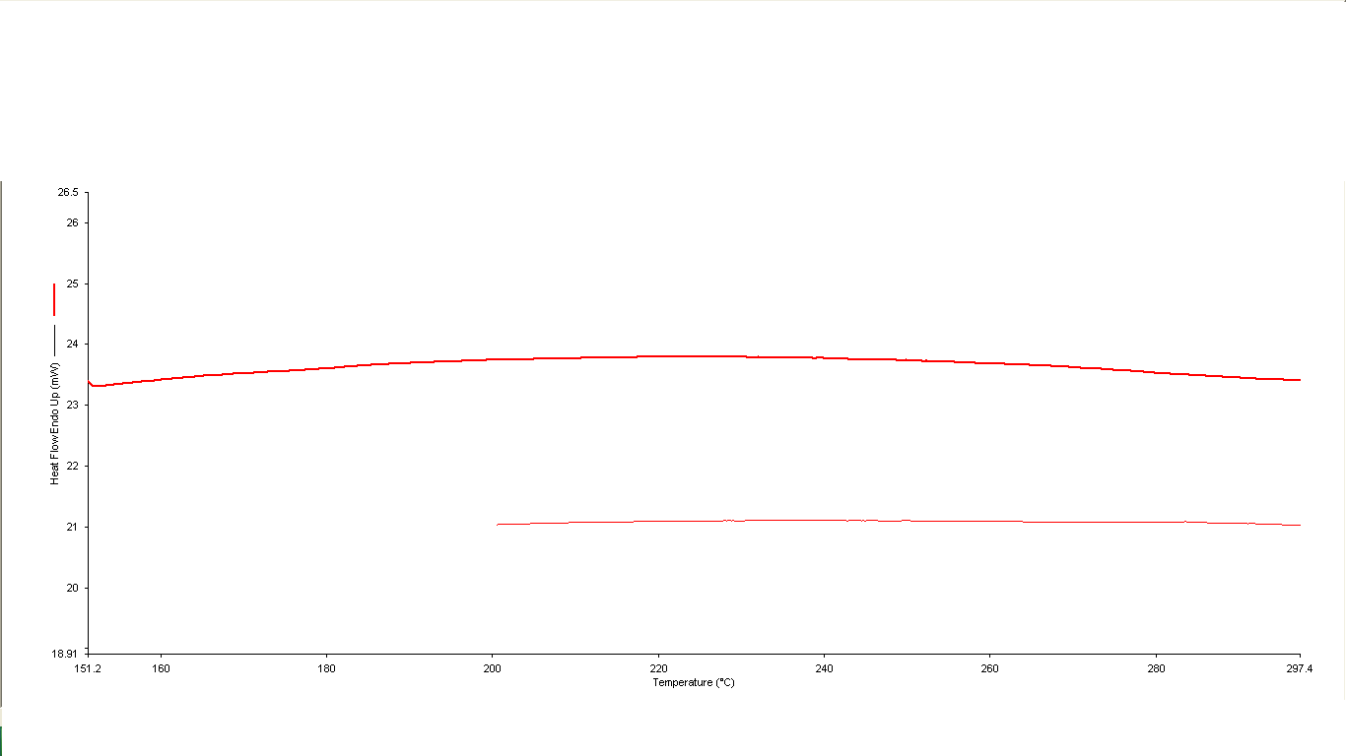

**Figure: DSC curve of HPMC-4KM**

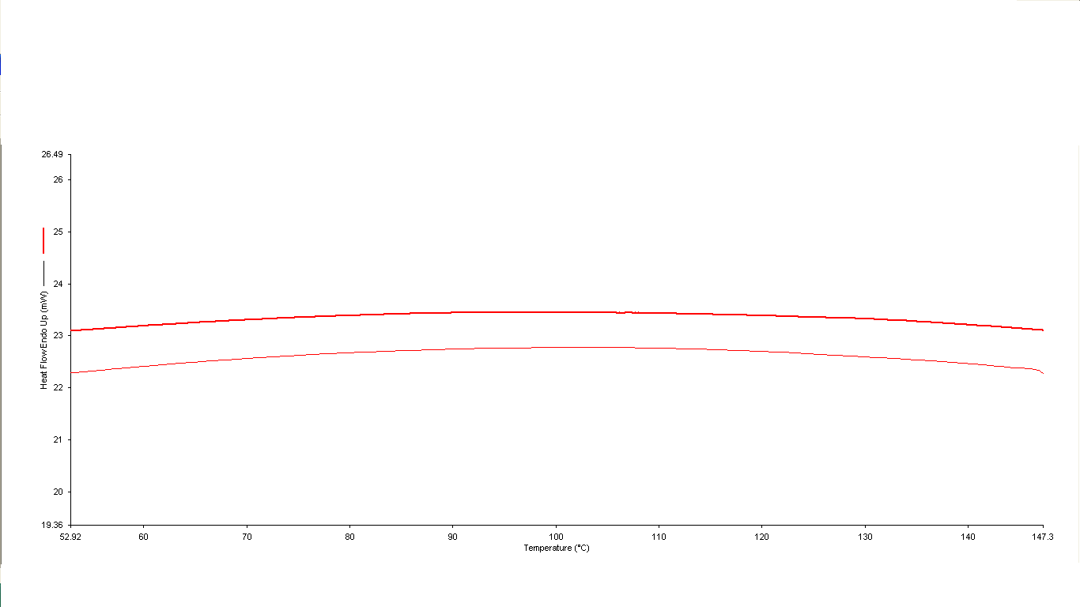

**Figure: DSC curve of Ethyl cellulose**

 **Figure: DSC curve of pamidronate disodium+ thiolated chitosan+HPMC-4KM+ethyl cellulose**

**Fig. 3: X-ray diffraction patterns of the drug, pure polymers and polymeric film formulations.**



**Figure: X-ray diffraction pattern of Pamidronate disodium**

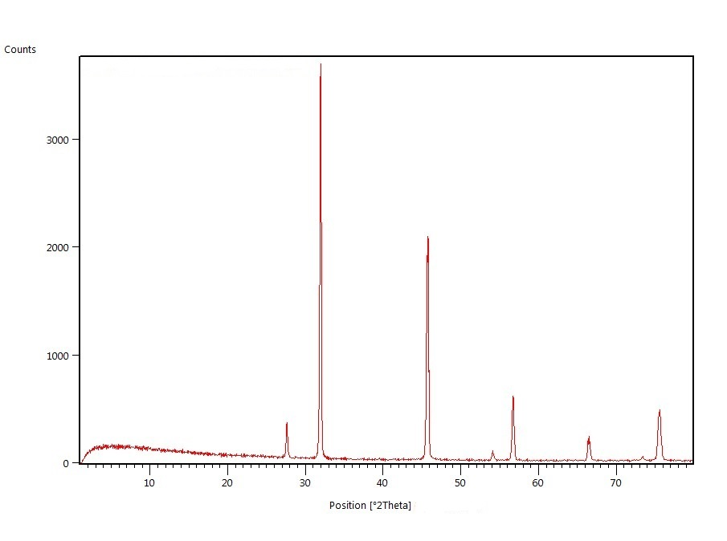

**Figure: X-ray diffraction pattern of Thiolated chitosan**



**Figure: X-ray diffraction pattern of HPMC-4KM**



**Figure: X-ray diffraction pattern of Ethyl cellulose**

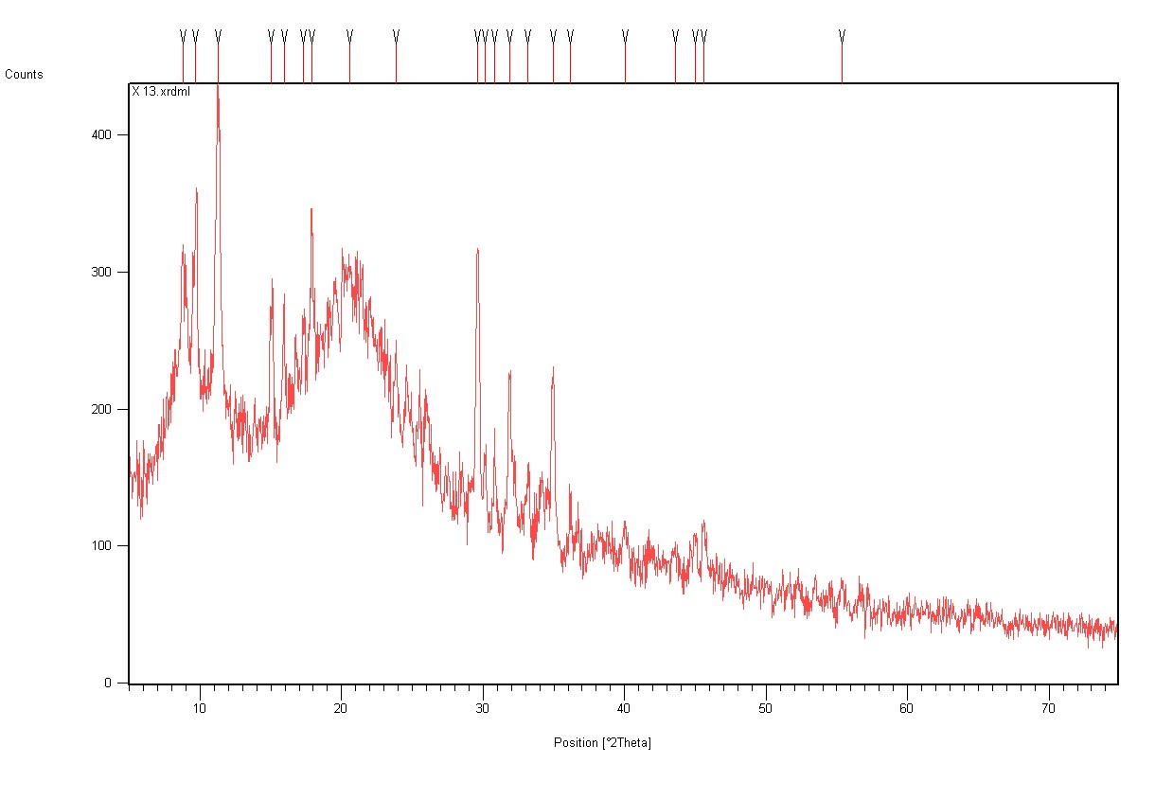

**Figure: X-ray diffraction pattern of Pamidronate + Thiolated chitosan+HPMC-4KM+Ethyl cellulose**