Appendices:
Appendix A: Additional tables and figures from methods and results
.
Figure A1: Map showing sampling locations of individual collected and amplified during the course of the study. Colors have to be used for this figure in print.
Figure A2: Results of divergence dating analysis and ancestral range estimation using DIVALIKE+j model following PTP analysis. Discrete areas are color coded as shown in the map. Most probable range inheritance scenarios are mapped on the tree as colored circles. Tips represent the present distribution of extant taxa included in the analysis. Multiple colored areas stand for distribution across different subdivisions. Colors have to be used for this figure in print. The horizontal bars at the nodes of the phylogeny represent 95% HPD of the divergence dates at respective nodes. The numbers next to node refer to node numbers in Appendix A Table A6. Colors have to be used for this figure in print.

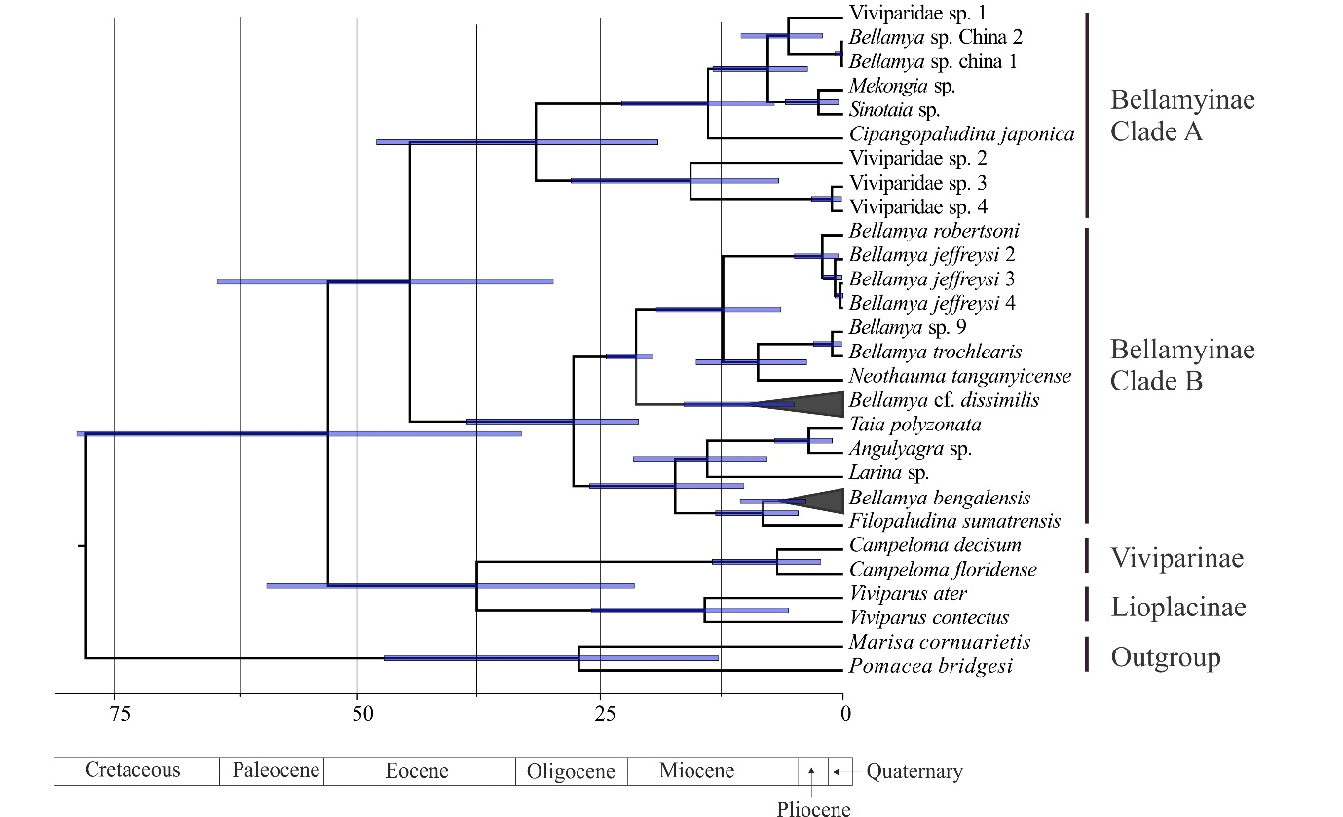
Figure A3: Results of divergence dating analysis using the dataset excluding ambiguous regions in noncoding genes. The horizontal bars at the nodes of the phylogeny represent 95% HPD of the divergence dates at respective nodes.

Table A1: A list of specimens from India used in the study with the sampling location
Species and individuals | Biogeographic subregion | Sample ID | Location | COI | 16S rRNA | 18S rRNA | 28S rRNA | Histone H3
Bellamya bengalensis 1 | IS | CES151289.1 | Bhavanisagar | # | # | # | # | #
Bellamya bengalensis 2 | IS | CES 151222.2 | Mirzapur | # | # | # | # | #
Bellamya bengalensis 3 | IS | CES 151252.2 | Swaimadhopur | # | # | # | # | #
Bellamya bengalensis 4 | IS | CES 16383.1 | Barwani | # | # | # | # | #
Bellamya bengalensis 5 | IS | CES 151115.1 | Krishnagiri | # | # | # | # | #
Bellamya bengalensis 6 | IS | CES 151180.1 | Adilabad | # | # | # | # | #
Bellamya bengalensis 7 | SEA | CES 16543.1 | Meleng | # | # | # | # | #
Bellamya bengalensis 8 | IS | M56 | Aurangabad | # | # | # | # | #
Bellamya bengalensis 9 | IS | ARS2 | Singampatti | # | # | # | # | #
Bellamya bengalensis 10 | SEA | 43 | Imphal | # | # | # | # | #
Bellamya bengalensis 11 | SEA | Chun2 | Kohima | # | # | # | # | #
Bellamya bengalensis 12 | SEA | Chun3 | Kohima | # | # | # | # | #
Bellamya cf. dissimilis 1 | IS | S.Sen | Coorg | # | # | # | # | #
Bellamya cf. dissimilis 2 | IS | CES 151209.2 | Mirzapur | # | # | # | # | #
Bellamya cf. dissimilis 3 | IS | CES 16321.1 | Baripada | # | # | # | # | #
Bellamya cf. dissimilis 4 | IS | CES 16389.1 | Mangod | # | # | # | # | #
Bellamya cf. dissimilis 5 | IS | CES 16516.1 | Pandharpur | # | # | # | # | #
Bellamya cf. dissimilis 6 | IS | 16523.1 | Beed | # | # | # | # | #
Bellamya cf. dissimilis 7 | IS | CES 16531.1 | Nagpur | # | # | # | # | #
Bellamya cf. dissimilis 8 | SEA | CES 16559.1 | Meleng | # | # | # | # | #
Bellamya cf. dissimilis 9 | IS | ARK1 | Konaje | # | # | # | # | #
Bellamya cf. dissimilis 10 | IS | ARS1 | Singmpatti | # | # | # | # | #
Viviparidae sp. 3 | SEA | Chun1 | Kohima | # | # | # | # | #
Viviparidae sp. 4 | SEA | ARM1 | S. Vanlaiphai | # | # | # | # | #

# sequences are yet to be submitted
Table A2: Sequences downloaded from genebank with accession numbers.
Species | Country | COI | 16S | 18S | 28S | H3
Species distributed in SEA and IS
Bellamya bengalensis | India | FJ405822 | FJ405724 | FJ405677 | FJ405622 | FJ405766
Species distributed in SEA
Angulyagra sp | Vietnam | FJ405819 | FJ405723 | FJ405675 | FJ405628 | FJ405769
Bellamya sp. | China | FJ405824 | FJ405725 | - | -
Bellamya sp. | China | FJ405826 | FJ405726 | - | - | FJ405776
Cipangopaludina japonica | USA* | FJ405821 | FJ405736 | FJ405639 | FJ405621 | FJ405777
Filopaludina sumatrensis | Singapore | FJ405834 | - | - | FJ405633 | FJ405770
Larina sp. | Australia | FJ405829 | FJ405733 | FJ405681 | FJ405626 | FJ405764
Mekongia sp. | Vietnam | FJ405820 | FJ405722 | FJ405676 |  | FJ405767
Sinotaia sp. | Vietnam | FJ405832 | FJ405728 | FJ405688 | FJ405631 | FJ405768
Taia polyzonata | Singapore | FJ405833 | FJ405727 | FJ405679 | FJ405632 | FJ405771
Viviparidae sp. 1 | China | FJ405831 | FJ405729 | FJ405687 | FJ405629 | -
Viviparidae sp. 2 | China | FJ405825 | FJ405730 | FJ405686 | - | FJ405775
Species distributed in Africa
Bellamya sp. 9 | Uganda | FJ405790 | FJ405703 | FJ405652 | FJ405611 | FJ405740
Bellamya jeffreysi 2 | Tanzania | FJ405804 | FJ405702 | FJ405656 | FJ405583 | FJ405761
Bellamya jeffreysi 3 | Tanzania | FJ405812 | FJ405700 | FJ405654 | FJ405584 | FJ405762
Bellamya jeffreysi 4 | Tanzania | FJ405806 | FJ405701 | FJ405651 | FJ405585 | FJ405763
Bellamya robertsoni | Malawi | FJ405802 | - | FJ405638 | FJ405581 | FJ405747
Bellamya trochlearis | Uganda | FJ405816 | FJ405691 | FJ405637 | FJ405603 | FJ405741
Neothauma tanganyicense | Zambia | FJ405788 | FJ405709 | FJ405643 | FJ405598 | FJ405739
Species distributed in the holarctic region
Viviparus ater | Switzerland | FJ405830 | FJ405734 | FJ405683 | FJ405630 | FJ405774
Viviparus contectus | Denmark | FJ405778 | FJ405692 | FJ405635 | FJ405634 | FJ405737
Campeloma floridens | USA | FJ405827 | FJ405731 | FJ405684 | FJ405624 | FJ405772
Campeloma decisum | USA | FJ405828 | FJ405732 | FJ405680 | FJ405625 | FJ405773
Outgroup
Marisa cornuarietis | South America | FJ439657 | EU274493 | EU274545 | EU274527 | EU274511
Pomacea bridgesii | South America | FJ439658 | EU274500 | EU274553 | EU274532 | EU274514

*Cipangopaludina japonica is introduced to the USA.
- No information can be found
Table A3: Partition schemes and models of sequence of evolution used for different analyses
RAxML |  | MrBayes |  | Beast
partitions | models | partitions | models | partitions | models
18S rRNA | GTR+I | 18S rRNA | JC | 18S rRNA, 28S rRNA | TrNef+G
H3 codon position 1, H3 codon position 2, COI codon position 2 | GTR+I | H3 codon position 1, H3 codon position 2, COI codon position 2 | JC | H3 codon position 1, H3 codon position 2, COI codon position 2 | K80
H3 codon position 3 | GTR+I | H3 codon position 3 | HKY+G | H3 codon position 3 | HKY+G
16S rRNA | GTR+I | 16S rRNA | GTR+G | 16S rRNA | GTR+G
28S rRNA, COI codon position 1 | GTR+I | 28S rRNA, COI codon position 1 | GTR+G | COI codon position 1 | TrNef+I
COI codon position 3 | GTR+I | COI codon position 3 | HKY+I+G | COI codon position 3 | HKY+I+G

Table A4: Results of species delimitation analysis:
Method | Species | individuals | Support
PTP | Species 1 | B. bengalensis 2, B. bengalensis 3, B. bengalensis 4, B. bengalensis 5, B. bengalensis 8 | 0.36
 | Species 2 | B. bengalensis 12 | 0.89
 | Species 3 | B. bengalensis 1 | 0.74
 | Species 4 | B. bengalensis 7 | 0.42
 | Species 5 | B. bengalensis 10 | 0.42
 | Species 6 | B. bengalensis 5, B. bengalensis 9 | 0.58
 | Species 7 | B. bengalensis 11 | 0.69
 | Species 8 | B. bengalensis (from Sengupta et al., 2009; see Table A2) | 0.69
PTP | Species 1 | Bellamya cf. dissimilis 3 | 0.88
 | Species 2 | Bellamya cf. dissimilis 2, Bellamya cf. dissimilis 4, Bellamya cf. dissimilis 7 | 0.58
 | Species 3 | Bellamya cf. dissimilis 5, Bellamya cf. dissimilis 6 | 0.59
 | Species 4 | Bellamya cf. dissimilis 1, Bellamya cf. dissimilis 9 | 0.35
 | Species 5 | Bellamya cf. dissimilis 8 | 0.7
 | Species 6 | Bellamya cf. dissimilis 10 | 0.81

Table A5: Model comparison for BioGeoBears analyses; significant P values, the highest log Likelihood score, the best AIC score, and the respective model are shown in bold:
Alternative | Null | Alt Likelihood | Null likelihood | Alt AIC | Null AIC | P value
BioGeoBears analyses following mPTP results
DEC+J | DEC | -26.6 | -30.18 | 59.16 | 64.36 | 0.0074
DIVALIKE+J | DIVALIKE | -24.64 | -25.82 | 55.27 | 55.65 | 0.12
BAYAREALIKE+J | BAYAREALIKE | -27.55 | -36.75 | 66.11 | 77.52 | 1.8e-05
BioGeoBears analyses following PTP results
DEC+J | DEC | -35.71 | -52.4 | 77.41 | 108.9 | 7.1e-09
DIVALIKE+J | DIVALIKE | -34.78 | -47.47 | 75.56 | 98.94 | 4.7e-07
BAYAREALIKE+J | BAYAREALIKE | -36.83 | -70.79 | 79.67 | 145.6 | 1.7e-16

Table A6: Probability of the estimated ranges at relevant nodes:
Node | Highest probability | Range | Second highest probability | Range
BioGeoBears analyses following mPTP results
1 | SEA | 0.98 | SEA-IS | 0.009
2 | SEA | 0.78 | SEA-IS | 0.20
3 | SEA-IS | 0.66 | IS | 0.14
4 | SEA | 0.98 | SEA-IS | 0.018
BioGeoBears analyses following PTP
1 | SEA | 0.92 | India | 0.05
2 | SEA | 0.87 | India | 0.12
3 | India | 0.98 | Africa | 0.0095
4 | India | 0.94 | SEA | 0.06
5 | SEA | 0.73 | India | 0.26
6 | SEA | 0.72 | India | 0.28
7 | India | 0.50 | SEA | 0.49
8 | India | 0.50 | SEA | 0.49
9 | India | 0.75 | SEA | 0.25
10 | India | 0.71 | SEA | 0.29
11 | SEA | 1 | India | 1.15e-24

Appendix B: Details on usage of fossil calibrations
- The oldest Bellamya bengalensis fossil, unearthed from the late Pliocene deposits in Jammu (Kundal, 2013), was used to calibrate the stem lineage of B. bengalensis. There are reports of B. bengalensis fossils from contemporary or slightly younger deposits from elsewhere in the IS such as Chandigarh (Bhatia & Mathur, 1973), Saketi (Mathur, 1998), Narmada valley (Prashad, 1928). Thus, it can be safely assumed that this lineage existed in IS at that specific period. A lognormal calibration with an offset of 2.2 mya was used because the lineage could not be younger than the age of the fossil (Ho and Phillips, 2009). The stem lineage was calibrated instead of the crown because the stem lineage might have existed much before the extant crown lineages started diversifying and the fossil could have belonged to any point in the stem lineage from the split from its sister group to the beginning of diversification in the crown. Calibrating the stem will make sure all these uncertainties will be taken into consideration. To allow for the uncertainty in time estimate of the age of the stem lineage the prior was given a broad enough range (2.2–8 mya). The upper age is based on a previous dating attempt that the authors have undertaken using the substitution rate of the COI gene.
- The oldest African Bellamyinid fossil, unearthed from the Iriri member of the Napak formation and is dated to early Miocene (~19 mya) (Pickford, 2004). A previous study on African Viviparids used this fossil to calibrate the root node of the phylogeny consisting of African Bellamyinid species (Schultheib et al., 2014). Here we used the same logic as before that the African lineage cannot be younger than 19 mya, and the fossil can belong to the stem lineage instead of the crown. Hence, we calibrated the stem African lineage with a lognormal prior and the offset was placed at 19 mya. The upper age of the distribution was 40 mya: the time when Africa collided with Eurasia (Van Yperen et al., 2005).

References:
Ho, S. Y., & Phillips, M. J., 2009. Accounting for calibration uncertainty in phylogenetic estimation of evolutionary divergence times. Syst. Biol., 58, 367-380.
Nath, K. S., 2013. Late Pliocene (Piacenzian Stage) Fossil Molluscs from Upper Siwalik subgroup of Jammu, Jammu and Kashmir, India. Int. res. J. earth sci. 1. 10-17.
Mathur A.K., 1998. Additional molluscan fauna and taxonomic review of molluscs from the Siwalik Group and terrace deposits, Himachal Pradesh, Punjab and Haryana, Geosci. J., 191, 33-75.
Prashad B., 1928. Recent and fossil Viviparidae - A study in distribution, evolution and palaeogeography, Memmoirs Indian Museum, 8, 153-251.
Bhatia S.B. and Mathur A.K.., 1973. Some Upper Siwalik and Late Pleistocene molluscs from Punjab, Himal. Geol., 3, 24- 58.
Pickford M, 2004. Palaeoenvironments of Early Miocene hominoid-bearing deposits at Napak, Uganda, based on terrestrial molluscs. Ann. Paléontol. 90, 1–12. https://doi.org/10.1016/j.annpal.2003.10.002
Van Yperen, G. C. N., Meijer P. Th., and Wortel, M. J. R., 2005. Rifting in a continental collision setting: the separation of Arabia from Africa. Geophys. Res. Abs. 7, 07396.
Schultheiß, R., Van Bocxlaer, B., Riedel, F., Von Rintelen, T., Albrecht, C., 2014. Disjuct distribution of freshwater snails testify to a central role of the Congo system in shaping biogegraphic patterns in Africa. BMC Evol. Biol. 14, 42. https://doi.org/10.1186/1471-2148-14-42

