**Short Communication** Manuscript for ***Journal of Power Sources***

**Tavorite LiFePO4OH Hydroxyphosphate as an Anode for**

**Aqueous Lithium-ion Batteries**

Lalit Sharmaa, Kosuke Nakamotob, Shigeto Okadab, Prabeer Barpandaa,*

a Faraday Materials Laboratory, Materials Research Center,

Indian Institute of Science, C.V. Raman Avenue, Bangalore, 560012, India.

b Institute for Materials Chemistry and Engineering (IMCE),

Kyushu University, 6-1 Kasuga-Koen, Kasuga, Fukuoka, 816-8580, Japan.

* author for correspondence

E-mail: [prabeer@iisc.ac.in](mailto:prabeer@iisc.ac.in)

Phone: +91 80 2293 2783; Fax: +91 80 2360 7316

**Supporting Information**

**Table S1.** Redox potentials of some selected cathode and anode materials used for aqueous lithium-ion battery.

**Figure S1.** Thermogravimetric analysis of LiFePO4OH showing the thermal stability of the sample till 400 oC.

**Figure S2.** Raman Spectra of LiFePO4OH showing the PO4-based bands.

**Figure S3.** Cyclic voltammogram of LiFePO4OH recorded between -1.0 V to 1.0 V vs. Ag/AgCl in aqueous 21 m LiTFSi + 7m LiOTf electrolyte.

**Figure S4.** (a) Galvanostatic potential-capacity profile of LiFePO4 half-cell in aqueous 21m LiTFSi + 7m LiOTf electrolyte; (b) Cyclability of the material for the initial 30 cycles.

**Figure S5.** Schematic and pictorial representation of setup of aqueous battery used for electrochemical measurements.

**Table S1.** Redox potentials of some selected cathode and anode materials used for aqueous lithium-ion battery.

|  |  |  |
| --- | --- | --- |
| **Material** | **Redox Potential** | **Reference** |
| LiFePO4 | 0.441 V vs. SHE | 1 |
| FePO4 | 0.26 V vs. SHE | 2 |
| LiCoO2 | 0.9 V vs. SHE | 3 |
| LiMnPO4 | 0.991 vs. SHE | 4 |
| VO2 (B) | -0.43 V vs. SHE | 5 |
| TiO2 | -0.9 V vs. SHE | 6 |
| LiV3O8 | -0.584 V vs. SHE | 7 |
| Polyimide | -0.5 V vs. SHE | 8 |
| LiFePO4OH | -0.35 vs. Ag/AgCl | This work |

**References:**

[1] Y. Hou, X. Wang, Y. Zhu, C. Hu, C. Chang, Y. Wu, R. Holze, Macroporous LiFePO4 as a cathode for an aqueous rechargeable lithium battery of high energy density, J. Mater. Chem. A 1 (2013) 14713-14718.

[2] M. Minakshi, Lithium itercalation into amorphous FePO4 cathode in aqueous solutions, Electrochim. Acta 55 (2010) 9174-9178.

[3] R. Ruffo, C. Wessells, R. A. Huggins, Y. Cui, Electrochemical behavior of LiCoO2 as aqueous lithium-ion battery electrodes, Electrochem. Commun. 11 (2009) 247-249.

[4] H. Manjunatha, T. V. Venkatesha, G. S. Suresh, Electrochemical studies of LiMnPO4 as aqueous rechargeable lithium-ion battery electrode 16 (2011) 1941-1952.

[5] J. Ni, W. Jiang, K. Yu, Y. Gao, Z. Zhu, Hydrothermal synthesis of VO2(B) nanostrucctures and application in aqueous Li-io battery, Electrochim. Acta 56 (2011) 2122-2126.

[6] M.-S. Wu, M.-J. Wang, J.-J. Jow, W.-D.. Yang, C.-Y. Hsieh, H.-M. Tsai, Electrochemical fabrication of anatase TiO2 nanostructure as an anode material for aqueous lithium-ion batteries, J. Power Sources 185 (2008) 1420-1424.

[7] L. L. Liu, X. J. Wang, Y. S. Zhu, C. L. Hu, Y. P. Wu, R. Holze, Polypyrrole-coated LiV3O8-nanocomposites with good electrochemical performance as anode material for aqueous rechageable lithium batteries, J. Power Sources 224 (2013) 290-294.

[8] H. Qin, Z. P. Song, H. Zhan, Y. H Zhou, Aqueous rechargeable alkali-ion batteries with polyimide anode, J. Power Sources 249 (2014) 367-372.

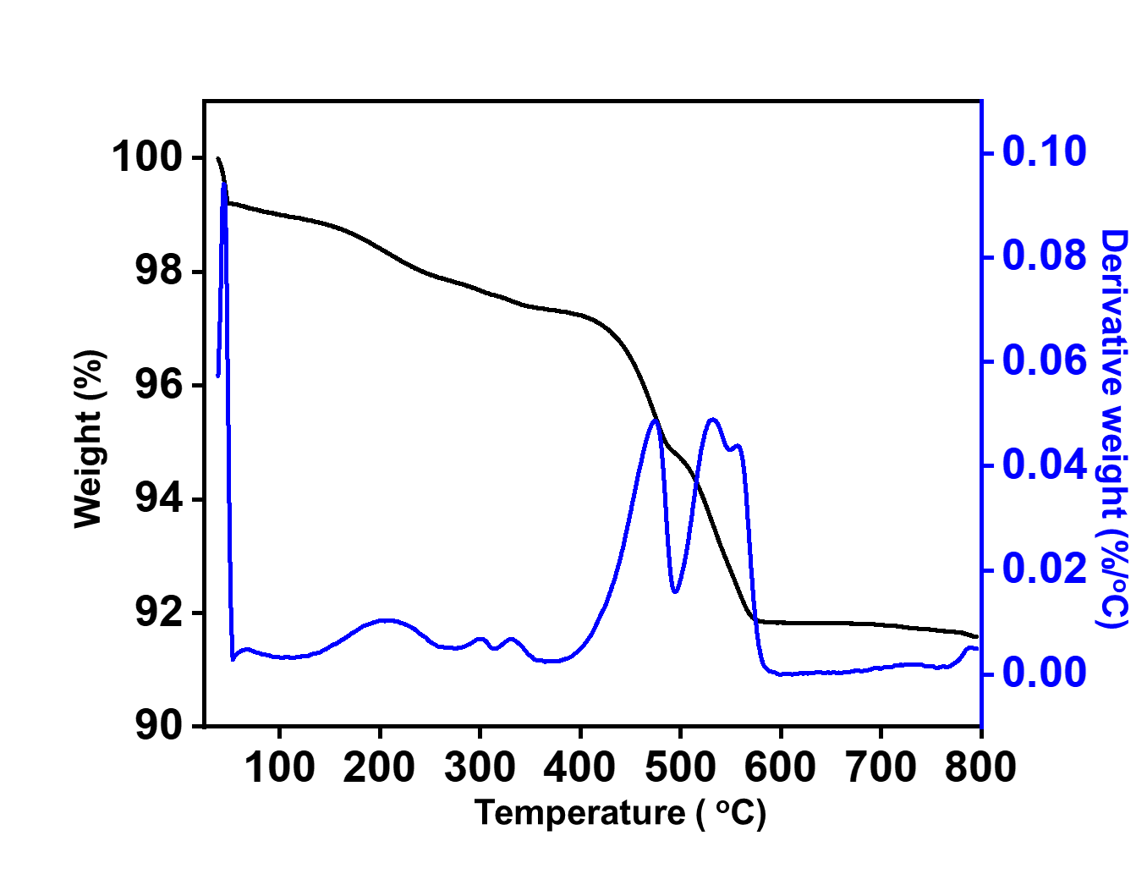

**Figure S1.** Thermogravimetric analysis of LiFePO4OH showing the thermal stability of the sample till 400 oC.

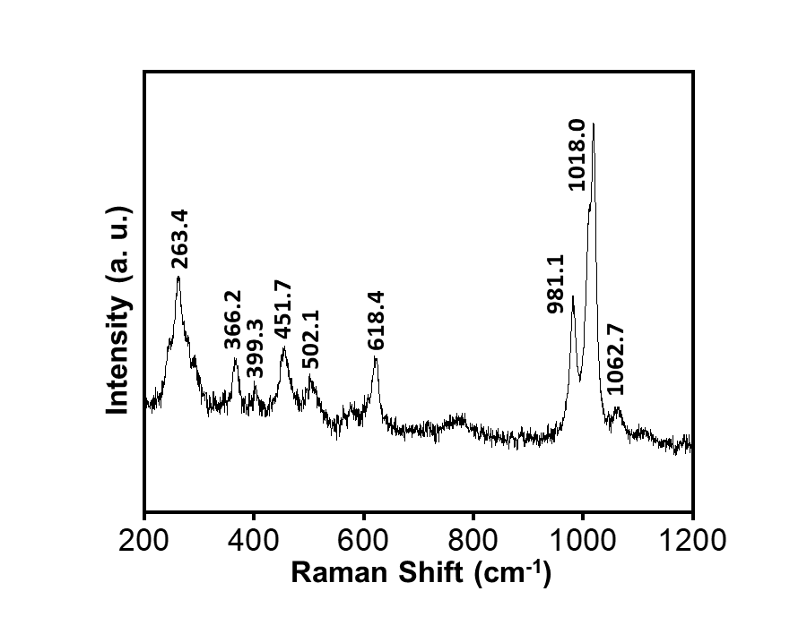

**Figure S2.** Raman Spectra of LiFePO4OH showing the PO4-based bands.



**Figure S3.** Cyclic voltammogram of LiFePO4OH recorded between -1.0 V to 1.0 V vs. Ag/AgCl in aqueous 21 m LiTFSi + 7m LiOTf electrolyte.

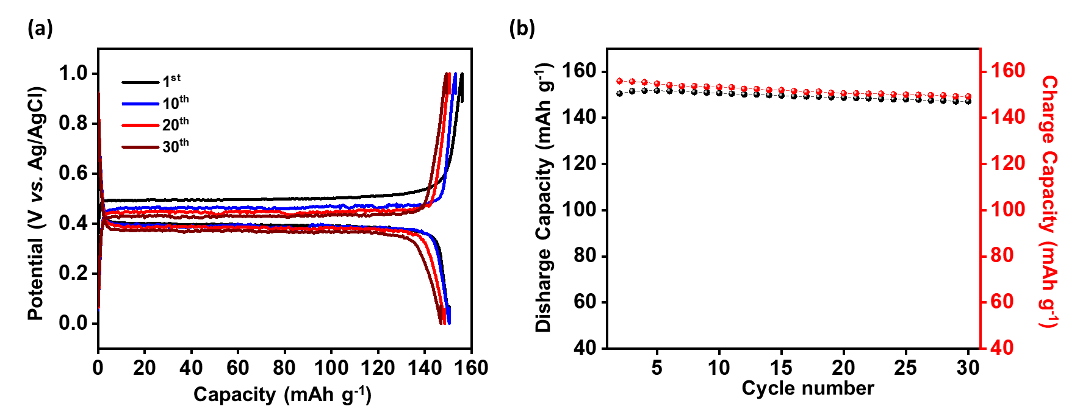

**Figure S4.** (a) Galvanostatic potential-capacity profile of LiFePO4 half-cell in aqueous 21m LiTFSi + 7m LiOTf electrolyte; (b) Cyclability of the material for the initial 30 cycles.

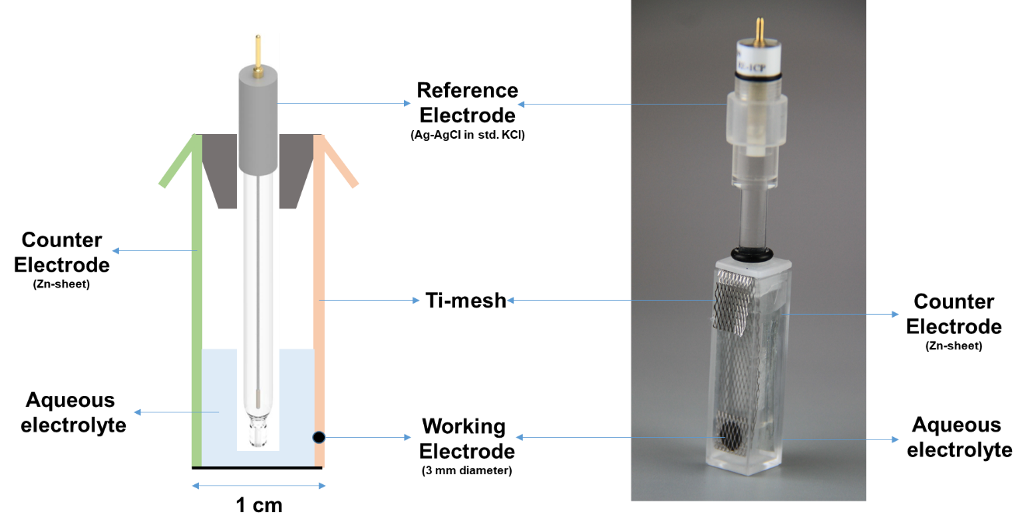

**Figure S5.** Schematic and pictorial representation of setup of aqueous battery used for electrochemical measurements.