Supplementary result
Electrochemical sensing and photo-catalytic degradation of Methylene Blue (MB) dye by Cobalt-beta Hydroxy benzoate complex

SangeethaSª, Dr.KrishnamurthyG^{a*} and Dr.M.Srinidhi Raghavan ^{b}

^{a, ∗}Department of Studies in Chemistry, Central College Campus, Bangalore University, Bangalore-560 001, India.
^{b}Centre for Nanoscience and Engineering, Indian Institute of Science, Bangalore-560012, India.

S1. NMR analysis of Co-bhb complex
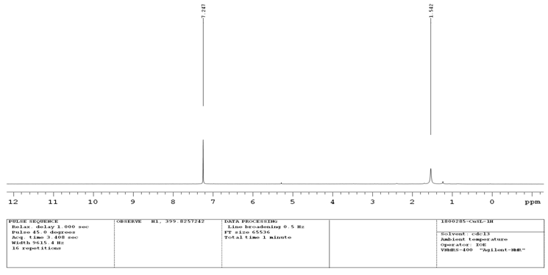

S2.Mass Analysis of Co-bhb complex
