Supporting Information

Inverted Perovskite Solar Cells with Air Stable Diketopyrrolopyrrole-based Electron Transport Layer
Shikha Sharma,ª Nobuya Sakai,^{b} Suman Ray,ª Satyaprasad P. Senanayak,^{c} Henning Sirringhaus,^{c} Henry J. Snaith^{b} and Satish Patilª*
ªSolid State and Structural Chemistry Unit, Indian Institute of Science, Bangalore-560012, India
^{b}Clarendon Laboratory, University of Oxford, Oxford OX1 3PU
^{c}Cavendish Laboratory, Department of Physics, University of Cambridge, Cambridge
CB3 0HE, United Kingdom

Corresponding author’s E-mail: spatil@iisc.ac.in

Table of Contents
1. Materials and Methods ……………………………………………………...............................................3
2. Synthesis and Spectroscopic characterization of TDPP-CN₄ …..….............................6
3. ¹H NMR and ¹³C NMR spectra for TDPP-CN₄………………………………………..…………………7
Figure S1. Cyclic voltammogram of TDPP-CN₄……………………….……………………………………….8
Figure S2. UV-visible spectrum of TDPP-CN₄ …………………………………………………………………9
Figure S3. Typical transistor characteristics of PCBM with L = 20 μm, W = 1 mm a) Output and b) transfer curves of PCBM …………………………………………………………………………..9
Figure S4. UV-visible spectra of perovskite precursors……………………………………….………….10
Figure S5. J-V curves and statistical distribution of device parameters for FA_{0.85}MA_{0.15}Pb(I_{0.8}Br_{0.2})₃ perovskite with PCBM/TDPP-CN₄ blends as ETM……………………10

1. Materials and Methods
All solvents were dried by standard methods. Chemicals were purchased from Aldrich, Acros Organics, S.D. fine chemicals, and Spectrochem and used without further purification. All reactions were performed in round bottomed flask equipped with reflux condenser under argon atmosphere. Column chromatography was performed on silica gel (100-200 mesh). The ¹H and ¹³C NMR spectra were recorded in CDCl₃ with TMS as an internal reference standard in Bruker Advance NMR spectrometer at 400 MHz. The chemical shifts were reported as δ values (ppm) relative to TMS. The UV-vis absorption spectra of the compounds were recorded with Perkin-Elmer (Lambda-35) spectrometer at room temperature in dichloromethane. Cyclic voltammetry measurements of TDPP-CN₄ were carried out in anhydrous DCM using 0.1 M TBAPF₆ as the supporting electrolyte where Ag/AgCl was employed as the reference electrode, platinum (Pt) as both working and counter electrode and ferrocene/ferrocenium (Fc/Fc⁺) redox couple as standard. Based on these measurements, the LUMO energy level for TDPP-CN₄ was calculated from the reduction onset as -4.46 eV using the equation E_{LUMO}= -[4.8-E_{Fc/Fc+}+E_{red}].
Fabrication of Perovskite solar cell: The patterned ITO substrates were purchased from Huayu Tech, Shenzhen, China with the size of 28×28 mm, the thickness is 1.1 mm and the square resistance is less than 10 Ω. The ITO substrates were first cleaned with 2% Hellmanex in water, and then were ultrasonically cleaned with deionized water, acetone, ethanol and iso-propanol for 10 min respectively. Before spin-coating, the substrates were treated with O₂ plasma for 10 min. The Poly(3,4-ethylenedioxythiophene):poly(styrene-sulfonate) (PEDOT:PSS, CLEVIOSTM P VP Al 4083, Heraeus) solution was first diluted with methanol (1:2, v/v). The films were spin-coated in air on a pre-cleaned ITO substrate at a spin-coating speed of 4000 rpm for 40 s. The films were then annealed at 150 °C for 10 min.
For methyl ammonium lead triiodide (MAPbI₃) perovskite, 3 M of CH₃NH₃I (MAI:Dyesol), 0.98 M of PbCl₂ (98%, Aldrich) and 0.02 M of PbI₂ (99%, Aldrich) were dissolved in dimethylformamide (dehydrate DMF; Aldrich). The perovskite precursor solution was coated onto the PEDOT layer by a consecutive two-step spin-coating process at 1300 rpm for 25 s and 3000 rpm for 15 under low humidity (15%–20% at 20 °C) condition with a dry compressed air parch in dry box. The perovskite films were quickly dried by the compressed air blowing for 30 s. The perovskite films were dried at 20 °C for 15 min and then 70 °C for 15 min on the hot plate. The dried films were annealed at 100 °C for 90 min then ramped up to 120 °C for 10 min in the box oven without controlling humidity.
For the mixed cation and halide precursor, 0.8 M formamidinium iodide (Dyesol), 0.16 M methylammonium bromide (Dyesol) or 0.16 M of cesium iodide (Alfa Aesar), 0.16 M lead bromide (Alfa Aesar), and 0.8 M lead iodide (TCI) were dissolved in a solvent mixture of N, N-dimethyformamide (DMF) and N, N-dimethyl sulfoxide (DMSO) (4:1 by volume) and stirred for 15 min at 65 °C. The perovskite deposition was done in a dry box with a RH of approximately 10%. For the deposition, 20 μL of the precursor solution was spin-coated per substrate in a two-step process, spinned for 10 s at 1000 rpm and 35 s at 6000 rpm, and 10 s before the end of the second spin-coating step, the spinning substrate was quenched with 200 μL anisole (Sigma-Aldrich) and chlorobenzene (Sigma-Aldrich) (9:1 by volume). Thereafter, the perovskite films were annealed at 100 °C in an oven. PCBM (20 mg) was added in 1 mL chlorobenzene and was stirred at 50 °C overnight. TDPP-CN₄ (10 mg) was dissolved in chlorobenzene. The solutions were filtered before use with 0.22 μm PTFE filter to remove possible large particles. Both of PCBM and TDPP-CN₄ layer were dynamically spin-coated on top of perovskite film at a speed of 1800 rpm for 40 s. All of the PCBM coated samples were annealed at 100 °C for 10 min after spin-coating on preheated hot plate. Due to the low solubility of BCP in IPA, the solution was heated at 100 °C under stirring for 1-2 h. After cooling down to room temperature, BCP solution was dynamically spin-coated on the top at a speed of 4000 rpm (5 s ramp) for 30 s. Silver electrodes (~100 nm) were thermally evaporated under vacuum of ~5×10⁻⁶ Torr, at a rate of ~0.1 nm s⁻¹. Note that the temperature of the vacuum chamber should be controlled under 40 °C during the evaporation of metal electrode, a higher temperature will cause possible degradation of perovskite films.
The current density–voltage (J-V) curves were measured (2400 Series SourceMeter, Keithley Instruments) under simulated AM 1.5 sunlight at 100 mW cm⁻² irradiance generated by an Abet Class AAB sun 2000 simulator, with the intensity calibrated with an NREL calibrated KG5 filtered Si reference cell. The mismatch factor was calculated to be less than 1%. The solar cells were masked with a metal aperture to define the active area, typically 9.19 mm² and measured in a light-tight sample holder to minimize any edge effects and ensure that the reference cell and test cell are located in the same spot under the solar simulator during measurement.

2. Synthesis and Spectroscopic characterization of TDPP-CN₄
Synthesis and Spectroscopic characterization of TDPP-CN₄: In a 50 mL round bottom flask, NaH (1.52 mmol, 60.8 mg) was suspended in 10 mL anhydrous tetrahydrofuran (THF) and malononitrile (0.76 mmol, 50 mg) was added to the flask at 0 ºC in inert atmosphere. The reaction mixture was then stirred for 30 minutes at room temperature to yield sodium malonate. In another 100 mL round bottom flask, the di-bromo DPP precursor (1) (0.32 mmol, 321 mg) and Pd(PPh₃)₄ catalyst (0.16 mmol, 183 mg) were mixed together in 20 mL anhydrous THF and refluxed at 85 ºC for 40 minutes. The sodium malonate afforded earlier was transferred to the reaction mixture through cannula and refluxed at 85 ºC for 12 hours. The mixture was later cooled to ice bath temperature, exposed to ambient conditions and diluted with hydrochloric acid (2 M, 60 mL). It was then allowed to attain room temperature (30 °C) and stirred for further 8 hours. The resulting solution was extracted with chloroform (3 × 100 mL), and the organic extracts were combined, washed with brine solution, and ultimately dried over Na₂SO₄. The solvents were evaporated using rotor vapor and the residue was purified by column chromatography on silica gel using petroleum ether/dichloromethane (DCM) followed by recrystallization from methanol to afford the final product as olive green solid in 58% isolated yield. M. P. 190-192 °C; ¹H NMR (400 MHz, CDCl₃) δ: 9.42 (2H, d, J = 6.0 Hz), 7.38 (2H, d, J = 5.6 Hz), 3.99 (4H, d, J = 7.6 Hz), 1.94-1.92 (2H, br m), 1.37-1.24 (64H, br m), 0.89-0.85 (12H, m); ¹³C NMR (100 MHz, CDCl3) δ: 173.0, 161.9, 147.5, 135.6, 134.0, 131.8, 131.2, 113.6, 112.8, 71.8, 47.6, 38.7, 32.3, 31.4, 30.5, 30.1, 29.8, 29.7, 26.5, 23.1, 14.6.

¹H NMR spectrum of TDPP-CN₄
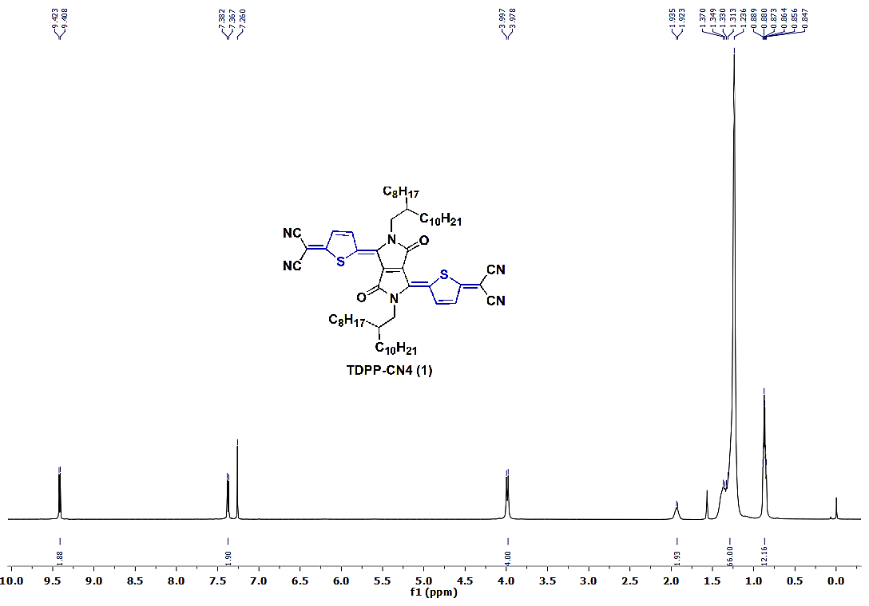

¹³C NMR spectrum of TDPP-CN₄

Figure S1. Cyclic voltammogram of TDPP-CN₄

Figure S2. UV-visible spectrum of TDPP-CN₄

Figure S3. Typical transistor characteristics of PCBM with L = 20 μm, W = 1 mm a) Output and b) transfer curves of PCBM

Figure S4. UV-visible spectra of perovskite precursors

Figure S5. J-V curves and statistical distribution of device parameters for FA_{0.85}MA_{0.15}Pb(I_{0.8}Br_{0.2})₃ perovskite with PCBM/TDPP-CN₄ blends as ETM

