Supporting Information

Protein functionalised self assembled monolayer based biosensor for colon cancer detection

Tarun Narayan^{a‡}, Saurabh Kumar^{b‡}, Suveen Kumar^{c}, Shine Augustineª, B. K. Yadav ^{d†}, Bansi D. Malhotra^{*a}

*Corresponding Author: bansi.malhotra@gmail.com

1. Materials and Methods
1.1 Real sample analysis.
The serum samples of CRC patients were received from the Rajiv Gandhi Cancer Institute & Research Centre (RGCI & RC), Rohini, Delhi (India). All the serum samples were collected under the protocol approved by Rajiv Gandhi Cancer Institute & Research Centre Institutional Review Board (R. No. RGCIRC/IRB/61). Written consent from each patient was obtained before collecting the real (serum) samples. Chloroform extraction method was utilized for removal of lipids from the serum samples. Further, the concentration of ET-1 in the serum sample was determined by the sandwich ELISA technique (RayBio Human Endothelin-1 ELISA Kit Catalogue No: ELH-EDN1). In this case, anti-ET-1 coated 96 microtiter-well plate was used, and ELISA was performed as per protocol (Section 2.2). The measurements were taken at 450 nm using ELISA plate reader (Bio-Rad Microplate Absorbance Reader). Thereafter, the fabricated anti-ET-1/11-MUA/Au SPR biosensor was used to determine the ET-1 concentration in the same samples, and the results were cross-validated to ELISA results. The patient serum samples were diluted with buffer (2×), and blank data was subtracted to minimize the interference.
1.2 ELISA assay protocol.
- The 8 well strips were labeled as standard and real sample, followed by addition of standard (200 µl) and real sample (200 µl) to each well and was kept for 2.5 h at room temperature.
- Biotin-labeled anti-ET-1 (100 µL) was added to each well and incubated for 1 h at room temperature. It was followed by washing with using the wash buffer.
- Subsequently,100 µl of streptavidin was added to each well and incubated for 45 minutes with gentle shaking. The solution was discarded and the washing was performed,
- Further, 100 µl of TMB was added to the wells for 30 minutes incubation at room temperature in the dark.
- Finally, 50 µl of stop solution was added, and the reading was measured using the ELISA plate reader at 450 nm, immediately.

2. Results
Figure S-1. (A) Calibration graph between responses vs. concentration of ET-1 of SPR immunosensor, (B) Calibration curve of the response of the immunoelectrode against ET-1 concentration (R_{ct} vs. log (ET-1 concentration)).

Figure S-2. Fitting of association curves using the monophasic model of interaction.

Figure S-3. Nyquist plots of bareAuelectrode , 11-MUA/Au, andEA/anti-ET-1/11-MUA/Au electrode in PBS containing 5 mM Fe(CN)₆^{3-/4-}.

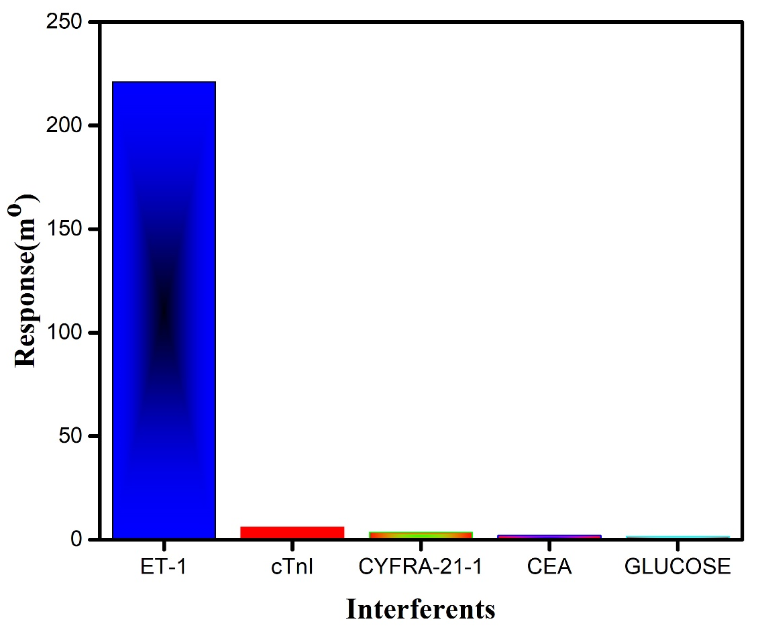

Figure S-4. Interferent study with different potent interferents present in serum.

Figure S-5. Comparison of response generated by the EA/anti-ET-1/11-MUA/Au SPR biosensor against the standard and patient samples (diluted 2X). (The concentration of ET-1 in standard samples, in each case, was kept equal to the corresponding patient samples as determined by ELISA.)

