Supporting Information
Highly ordered Iron oxide-mesoporous fullerene nanocomposites for oxygen reduction reaction and supercapacitor applications

Mercy R. Benzigar,^{a,b} Stalin Joseph,^{a,b} Gopalan Saianand,^{a,b}* Anantha-Iyengar Gopalan^{c}, Sujoy Sarkar,^{d} Sampath Srinivasan,^{d} Dae-Hwan Park,^{a,b} Sung-Ho Kim,^{b} Siddulu Naidu Talapaneni,^{a,b} Kavitha Ramadass,^{a,b} and Ajayan Vinu^{a,b}*
ªGlobal Innovative Center for Advanced Nanomaterials, Faculty of Engineering and Built Environment, The University of Newcastle, Callaghan Campus, New South Wales 2308, Australia
Email*: Ajayan.Vinu@newcastle.edu.au; SaiAnand.Gopalan@newcastle.edu.au

^{b}Future Industries Institute, Division of Information Technology, Engineering and Environment, University of South Australia, Mawson Lakes, South Australia 5095, Australia
^{c}Research Institute of Advanced Energy Technology, Kyungpook National University, Daegu 41566, South Korea
^{d}Department of Inorganic and Physical Chemistry, Indian Institute of Science, Bangalore 560 012, Karnataka, India

Electrochemical assembly and electrode preparation for ORR and supercapacitor studies
- Electrode fabrication for ORR
To study the electrochemical activity of ORR, a conventional three-electrode electrochemical cell was employed and electrochemical measurements were carried out at room temperature in 0.5 M KOH solution. Modified glassy carbon electrodes (GCE), Hg/HgO, OH⁻ (Mercury/mercuric oxide, MMO) and Pt foil were utilized as working, reference and counter electrodes, respectively. The measured potentials vs MMO were calibrated into reversible hydrogen electrode (RHE) scale according to the Nernst equation ($E_{RHE}= E_{MMO}+0.098V+0.059*pH$). The slurry for was prepared by modifying GCE by dispersing 1 mg of electrocatalyst (Fe-SBA-15-T) in 60 μL (catalyst loading : 0.285 mg cm⁻²) of ethanol containing a trace amount of 5% Nafion which was ultrasonically dispersed for ~ 30 min to obtain a homogenous ink. After pre-cleaning and mirror polishing the GCE (5 mm diameter, 0.196 cm² geometric area) with 0.05 μm alumina solution the catalyst, a desired quantity (4 μL) of the prepared ink was carefully drop casted on the surface of GCE. The electrolyte was purged with high-purity oxygen (O₂) and nitrogen (N₂) gases prior to the electrochemical studies of ORR. O₂ flow was maintained over the electrolyte during the experiment to ensure the O₂ saturation of the electrolyte. Cyclic voltammograms (CVs) and linear sweep voltammetry (LSV) plots were employed to investigate the electrochemical behaviour and ORR kinetics of the prepared electroactive catalyst.
Rotating disc electrode (RDE) measurements were performed using the RDE system obtained from CH electrochemical workstation (Model 660a) coupled with the potentiostat. CVs were recorded in 0.5 M K OH in the presence of N₂ and O₂ environment (potential range: 0.2 to 1.0 V vs RHE) at a scan rate (ν) of 100 mVs⁻¹. Similarly, LSV was swept at a ν of 5 mVs⁻¹ at different rotating speeds (ω) (100 to 2000 rpm) in O₂ saturated 0.5 M KOH. The methanol tolerance activity of the catalyst was performed at 1600 rpm at a ν of 5 mVs⁻¹ in alkaline medium (0.5 M KOH).
To gain further insights into the kinetics of ORR, Koutecky–Levich (K-L) plot, a linear relationship between the inverse of kinetic current (j_{k}⁻¹) vs inverse of square root of rotating rate (ω^{-1/2}) of electrode, were plotted, where the slopes of the parallel lines were used to determine the number of electron transferred per oxygen molecule (n) for ORR. The n value was calculated from the following equation using K-L plot from the equation
$$\frac{1}{j}= \frac{1}{j_{k}}+ \frac{1}{j_{L}}= \frac{1}{B} ω^{-1/2}+ \frac{1}{j_{k}}$$
where, j, j_{k} and j_{L} are the measured, kinetic-controlled, mass-transfer limited current densities, respectively and ω is the electrode rotating rate. Then, the proportionality constant (B) or the levich slope can be extracted from the following equation,
$$B=0.62 nFC_{o}{D^{2/3}v}^{-1/6}ω^{1/2}$$
where, n indicates the number of electron transfer per oxygen molecule, F is the Faraday constant (F = 96485 c mol⁻¹), C₀ is the oxygen concentration in the electrolyte (C₀ = 1.20×10⁻⁶ mol/m³), D is the diffusion coefficient of the oxygen (D =1.90×10-5 cm² s⁻¹), and $v$ is the kinematic velocity (ν= 0.01 cm² s⁻¹). Thus, n can be deduced from the slope of linear plot of j⁻¹ vs ω^{−1/2}.
- Electrode fabrication for supercapacitor
The electrochemical measurements for supercapacitance studies were conducted on a CHI 760C electrochemical workstation in a standard three-electrode system where modified nickel mesh, Pt wire and Ag/AgCl serve as working, counter, and reference electrodes, respectively. The active material was prepared with a conducting material (Fe-MFC₆₀), carbon black and the binder polytetrafluoroethylene (PTFE) in the ratio of 85:5:10. The slurry was prepared by blending the active material with carbon black and the binder and then pasted on the Ni mesh and dried at 90 °C for 12 h in vacuum oven. The supercapacitor studies were carried out using 2 M KOH as the supporting electrolyte. All the studies were carried out under atmospheric conditions.

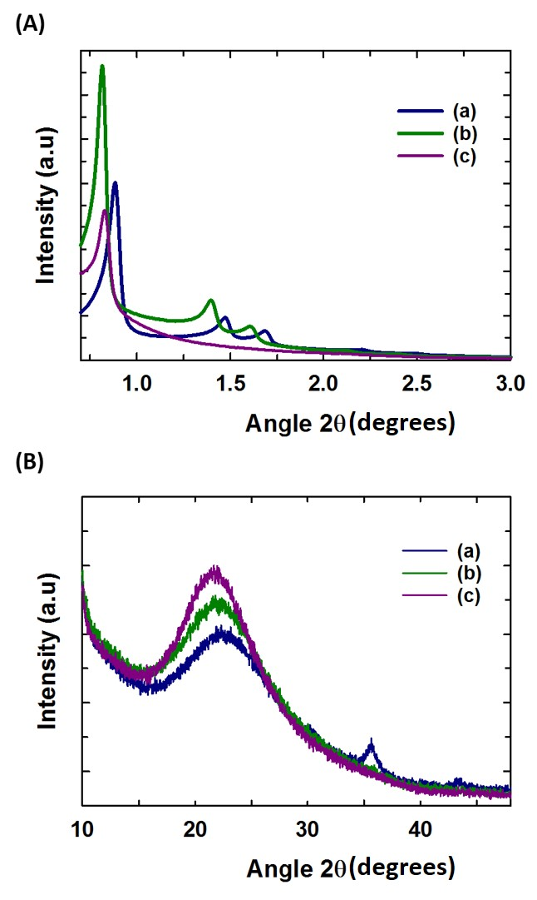
Figure S1. (A) Low and (B) high angle XRD patterns of (a) Fe-SBA-15-130, (b) Fe-SBA-15-150, and (c) Fe-SBA-15-200.

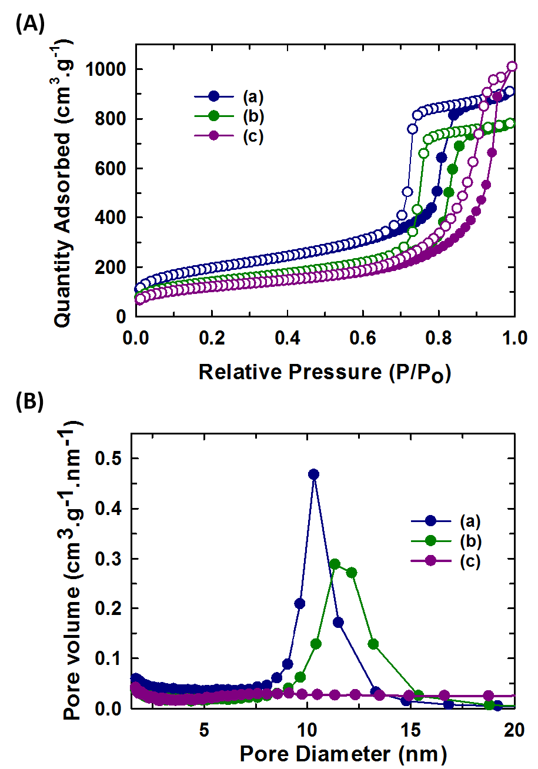
Figure S2. (A) N₂ adsorption-desorption isotherm curves and (B) its corresponding BJH pore size distribution of (a) Fe-SBA-15-130, (b) Fe-SBA-15-150 and (c) Fe-SBA-15-200.

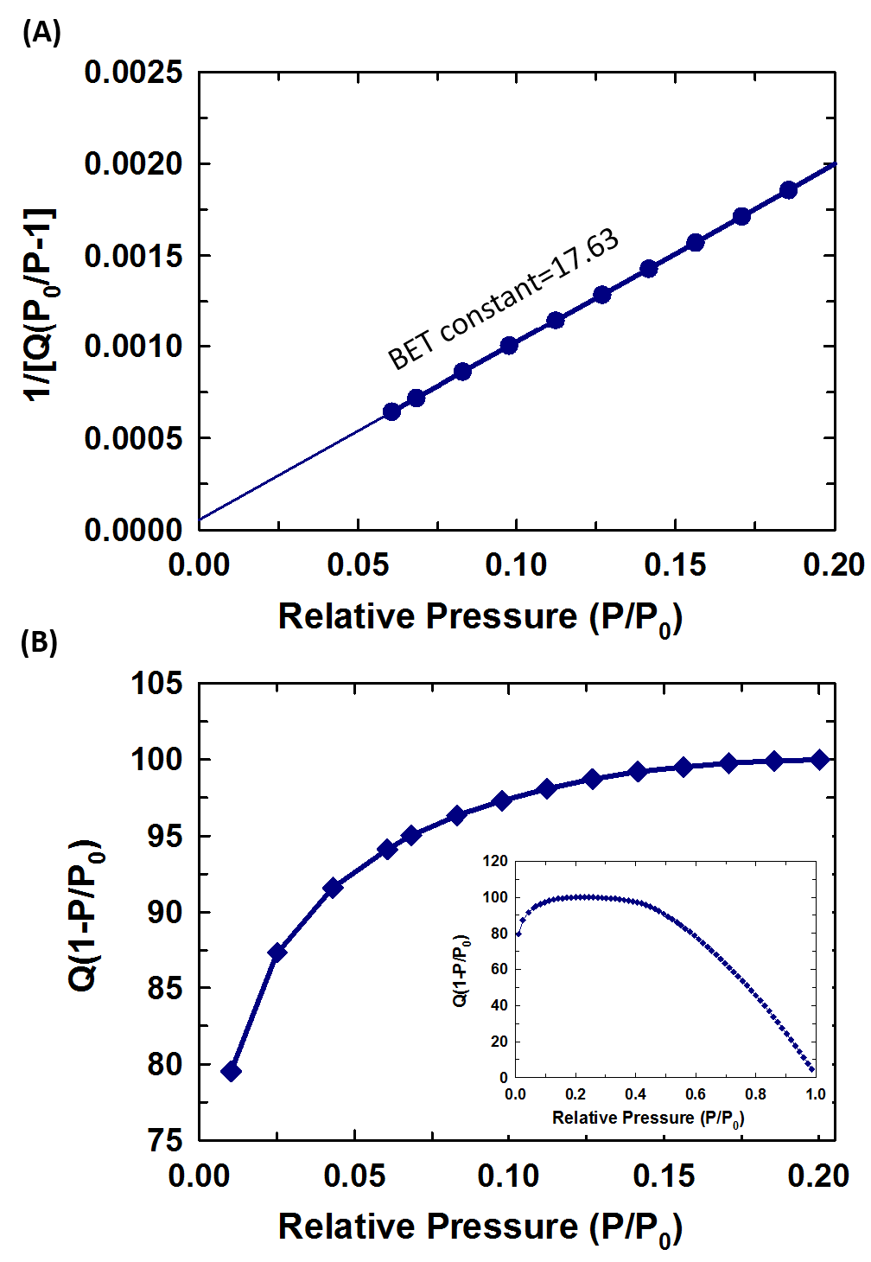
Figure S3. (A) BET surface area report with a value of BET constant and (B) the Rouquerol plot with the pressure ranges used for the BET surface area calculations for Fe-MFC₆₀-130, with its calculated Rouquerol plot (inset).
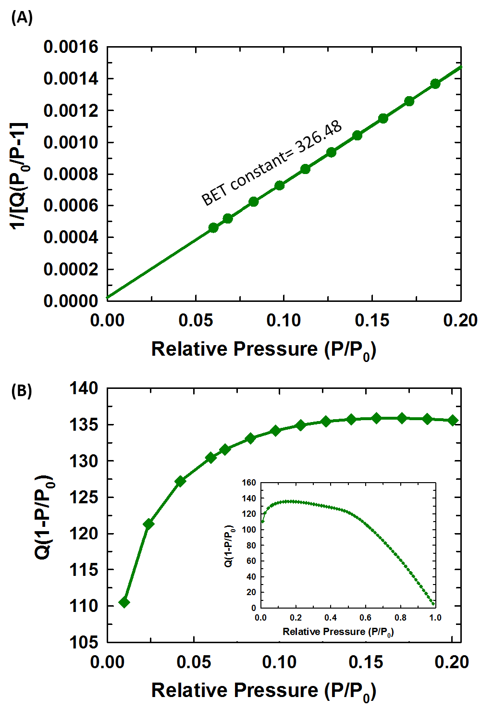
Figure S4. (A) BET surface area report with a value of BET constant and (B) the Rouquerol Plot with the pressure ranges used for the BET surface area calculations for Fe-MFC₆₀-150, with its calculated Rouquerol plot (inset).
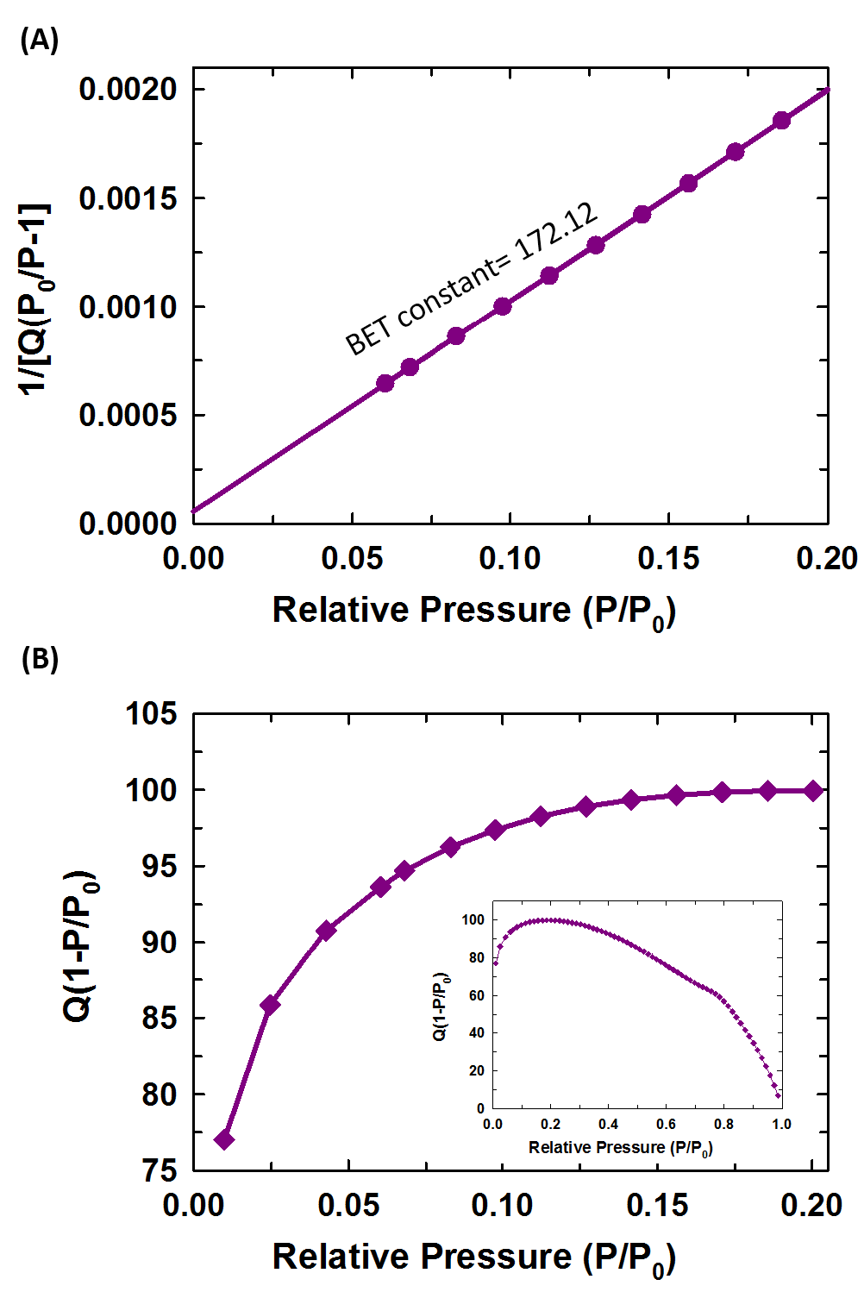
Figure S5. (A) BET surface area report with a value of BET constant and (B) the Rouquerol Plot with the pressure ranges used for the BET surface area calculations for Fe-MFC₆₀-200, with its calculated Rouquerol plot (inset).

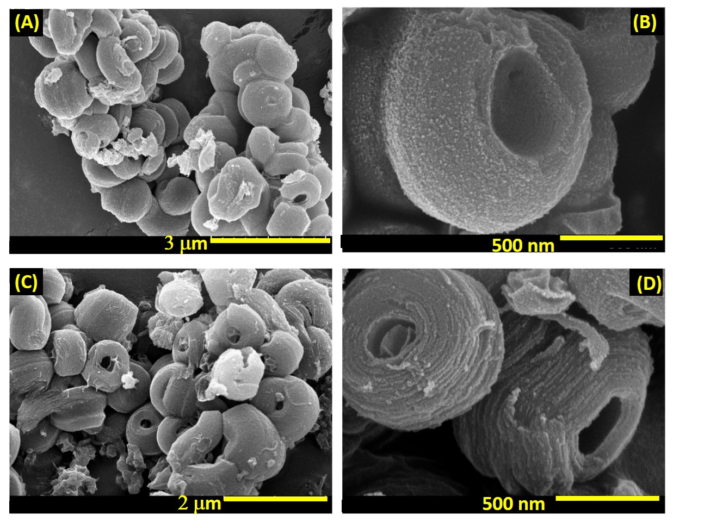
Figure S6. (A, C) Low and (B, D) high magnification HR-SEM images of Fe-MFC₆₀-100 and Fe-MFC₆₀-130.

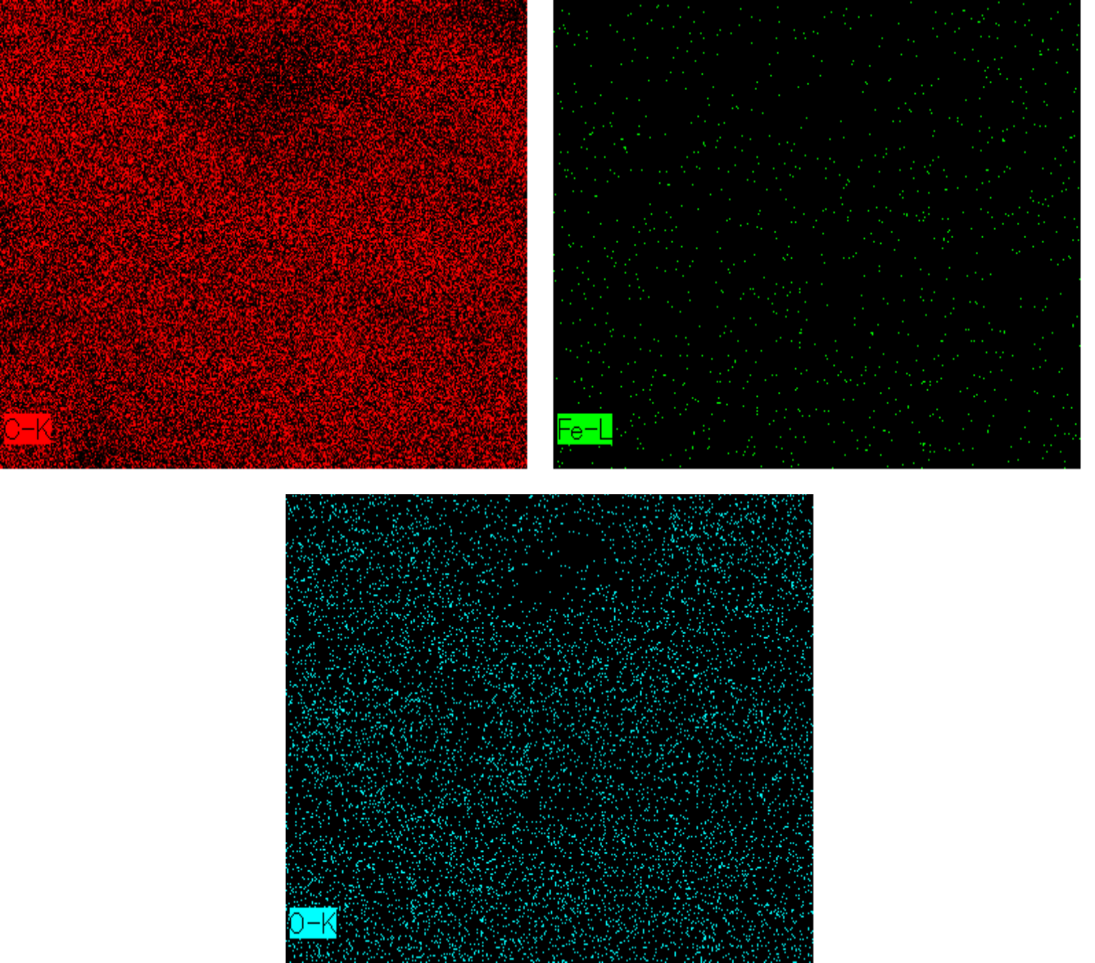
2μm
2μm
2 μm

Figure S7. EDS mapping of Fe-MFC₆₀-130.

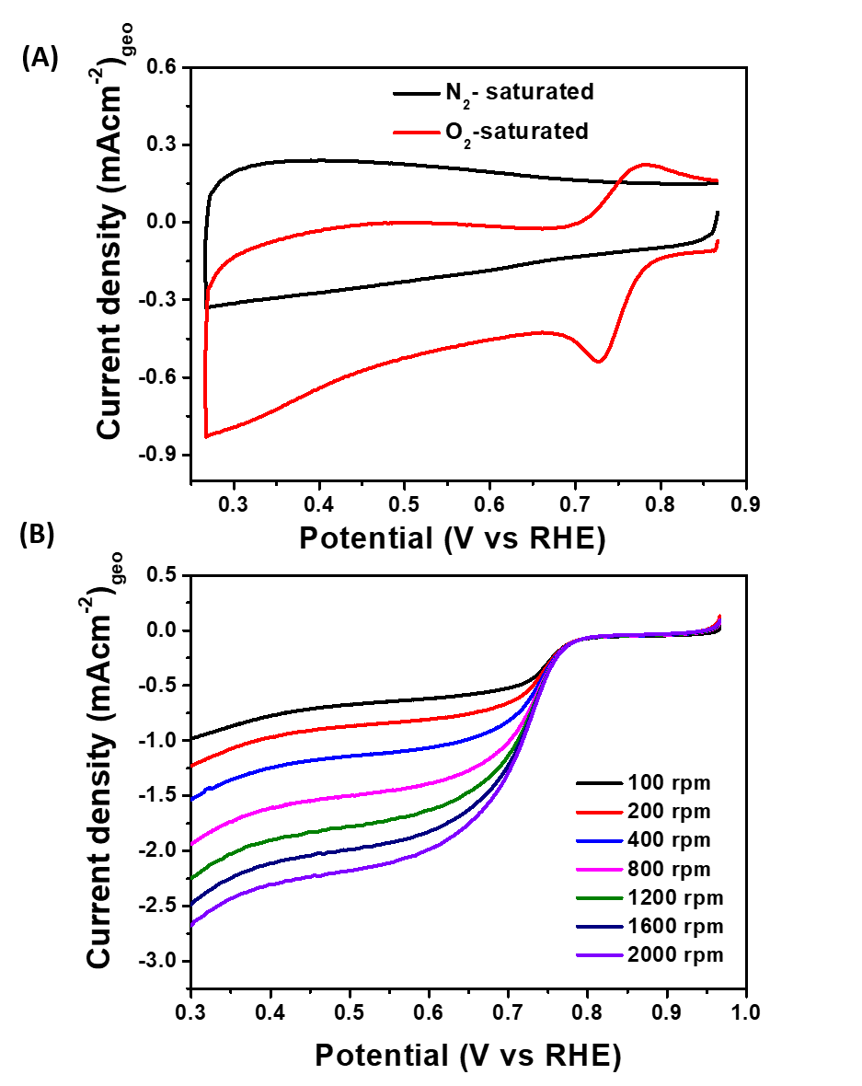

Figure S8. (A) Cyclic voltammograms (CV) curves of Fe-MFC₆₀-130 in the presence of N₂- and O₂-saturated 0.5 M KOH electrolyte at scan rate of 10 mVs⁻¹ and (B) LSV curves of Fe-MFC₆₀-130 in saturated O₂ at different rotation speeds (100 to 2000 rpm) (Scan rate:5 mV s⁻¹).
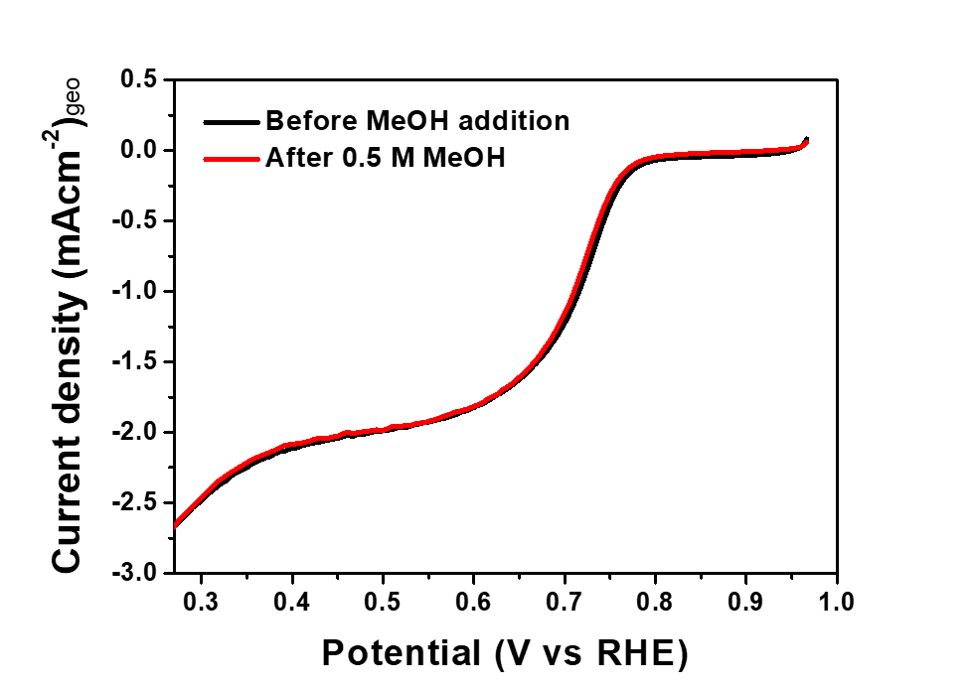
Figure S9. The methanol tolerance of Fe-MFC₆₀-130 performed at 1600 rpm (Scan rate: 5 mVs⁻¹) before and after the addition of 0.5 M methanol.
Table S1: Comparison of other representative carbon electrode materials and their supercapacitor performance.
Nanostructured carbon materials | Supercapacitor performance | Reference
Carbon nanotube (CNT) | 16 F/g at 10 mA g⁻¹ | [1]
Modified CNT | 35 F/g at 10 mVs⁻¹ | [1]
Multiwalled carbon nanotubes (MWCNTs) | 85 F/g at 0.4 A/g | [2]
Hierarchical porous carbon | 229 F/g at 1 A/g | [3]
Onion derived porous carbon | 179.5 F/g at 0.5 A/g | [4]
Hierarchical porous carbon sheets from cornstack | 407 F/g at 1 A/g | [5]
Graphene enriched carbon aerogel | 335 F/g at 0.1 A/g | [6]
References:
[1] M. Skunik, M. Chojak, I.A. Rutkowska, P.J. Kulesza, Improved capacitance characteristics during electrochemical charging of carbon nanotubes modified with polyoxometallate monolayers, Electrochimica Acta, 53 (2008) 3862-3869.
[2] S.H. Aboutalebi, A.T. Chidembo, M. Salari, K. Konstantinov, D. Wexler, H.K. Liu, S.X. Dou, Comparison of GO, GO/MWCNTs composite and MWCNTs as potential electrode materials for supercapacitors, Energ Environ Sci, 4 (2011) 1855-1865.
[3] J. Cao, C. Zhu, Y. Aoki, H. Habazaki, Starch-Derived Hierarchical Porous Carbon with Controlled Porosity for High Performance Supercapacitors, ACS Sustainable Chemistry & Engineering, 6 (2018) 7292-7303.
[4] W. Zhang, J. Xu, D. Hou, J. Yin, D. Liu, Y. He, H. Lin, Hierarchical porous carbon prepared from biomass through a facile method for supercapacitor applications, Journal of Colloid and Interface Science, 530 (2018) 338-344.
[5] C. Wang, D. Wu, H. Wang, Z. Gao, F. Xu, K. Jiang, A green and scalable route to yield porous carbon sheets from biomass for supercapacitors with high capacity, Journal of Materials Chemistry A, 6 (2018) 1244-1254.
[6] X. Yang, X. Zhuang, Y. Huang, J. Jiang, H. Tian, D. Wu, F. Zhang, Y. Mai, X. Feng, Nitrogen-enriched hierarchically porous carbon materials fabricated by graphene aerogel templated Schiff-base chemistry for high performance electrochemical capacitors, Polymer Chemistry, 6 (2015) 1088-1095.

