Supporting Information
HDPE/UHMWPE hybrid nanocomposites with surface functionalised graphene oxide: towards improved strength and cytocompatibility
Shardul Atul Bhusari^{aǂ}, Vidushi Sharma^{aǂ}, Suryasarathi Bose^{b,}*, Bikramjit Basu^{a,c,}*
ª Laboratory for Biomaterials, Materials Research Centre, Indian Institute of Science, Bangalore 560012, India
^{b} Department of Materials Engineering, Indian Institute of Science, Bangalore 560012, India
^{c} Centre for Biosystems Science and Engineering, Indian Institute of Science, Bangalore 560012, India
^{ǂ Equal Contribution}
Corresponding Authors:
*E-mail: bikram@iisc.ac.in
*E-mail: sbose@iisc.ac.in

Optimization of HDPE/UHMWPE blend
The twin screw extrusion of a polymer blend with UHMWPE required appropriate optimization of the processing parameters and weight fractions of UHMWPE in the polymeric blend. Three different compositions with varying weight fractions of HDPE and UHMWPE (60% HDPE / 40% UHMWPE, 50% HDPE / 50% UHMWPE and 40% HDPE / 60% UHMWPE,) were explored. It was found that during the processing, the blend with 50% wt. fraction of UHMWPE saw an abrupt increase in the force generated inside the twin-screw extruder due to the blend’s higher melt viscosity. The cut-off limit of 8 kN was reached, before a stable value of force was reached. Subsequently, the extruder was shut down, leading to improper mixing. Thus, the UHMWPE addition was limited to 40% by weight as it led to optimum mixing of the nanocomposite blends. In situ measurements of force, screw torque, melt viscosity and shear stress were recorded during the processing (Figure S1). It is also worthwhile to note that the addition of unmodified and modified GO to HU (60% HDPE / 40% UHMWPE) did not alter the above mentioned properties in situ.

Figure S1: In situ behaviour of HU blend, 1GO, 1mGO and H50-U50 blend, composite in the twin-screw melt extruder: (a) Force vs. time; (b) Melt viscosity vs. time; (c) Shear stress vs. time; (d) Screw torque vs. time.
Static contact angle measurements
The surface wettablity study is helpful as hydrophobicity and hydrophilicity of a substrate affect the viability, proliferation and growth of cells. The surface wettability of different compositions of the reinforced HU blend was performed using a Goniometer (OCA 15EC, Data Physics instruments, Germany). The sessile drop method was used for the geometries with a smooth surface for static contact angle measurement of the nanocomposites with both distilled water and Dulbecco's Modified Eagle Medium (DMEM) cell culture media, in ambient conditions. Contact angle measurements were taken over different areas of the same sample and the standard deviation of the results from both the surfaces is analysed.It was observed that the addition of 0.5 wt.% of GO is making surface more hydrophilic compared to the neat blend, in case of both the probing liquids. Whereas, the surface of nanocomposites showed more hydrophobic behaviour with the incorporation of 0.5 wt.% mGO. It was seen that for 1GO and 1mGO, the contact angle has increased from 60° to 67° for DI water while there was no significant variation for cell culture media (59° to 61°) (refer Figure S2). With incorporation of GO, the static contact angle showed a linear increase with increasing nanofiller amount i.e. the surface became more hydrophobic. Due to the presence of hydrophobic polyethylene wrapped over graphene oxide (mPE grafted over GO-PEI), the hydrophobicity of the mGO reinforced nanocomposites increased. It is therefore quite likely that the hydrophilic groups (e.g. C-O, C=O, etc.) on GO are no more exposed due to PE grafting, resulting in an increase in hydrophobicity after reinforcement with mGO.(1)(2) The localisation of nanofiller, slight irregularities in moulded samples and instrument sensitivity led to deviation in contact angle values over same substrate.
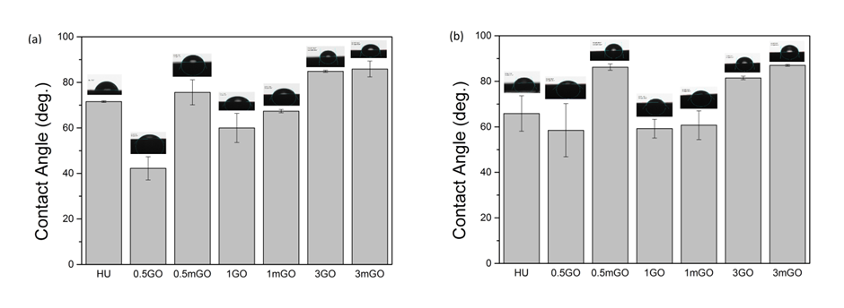
Figure S2: Static contact angle measurements on different nanocomposites of HU with GO and mGO with probe liquids (a) DI water, (b) DMEM (cell culture media). For the material grade compositions mentioned in the figure, please refer to Table 1.
Although the hydrophobicity of the mGO-HU surface increases relative to the GO-HU, the contact angle still remains in the range for hydrophilic surfaces (less than 90°) and thus supports the growth and proliferation of cells on the surface of the substrate.
Optical micrographs of the nanocomposites
The dispersion of GO and mGO in the HU blend was also analysed with the help of optical microscopy. Photomicrographs of thin sheets, prepared using compression moulding of the nanocomposite samples, were taken at 10× magnification on an optical microscope (Nikon LV 100D, Japan). Optical micrographs of thin compression moulded films of the nanocomposites (Figure S3) reveal that the modified graphene oxide in 1mGO sample is evenly dispersed in the HU blend matrix at the micro-scale. The dispersion in case of 1GO, on the other hand, is not very uniform as a result of the agglomeration or restacking of unmodified GO nanoparticles within the HU polymer matrix.
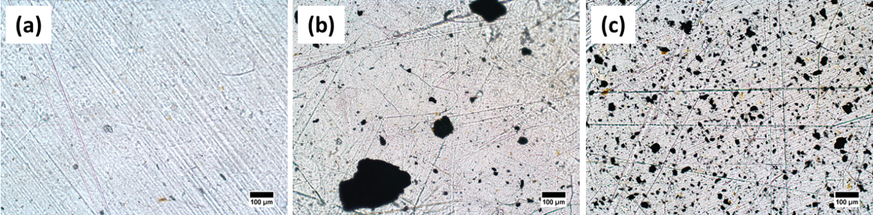
Figure S3: Optical micrographs of (a) HU, (b) 1GO and (c) 1mGO showing the dispersion of GO and mGO nanofillers within the HU blend matrix. (Scale bar: 100 µm).
References
1. Wu S, Ran Q, Liu Z. Polymer-Plastics Technology and Engineering Studies on Structure and Properties of HDPE Functionalized Through Ultraviolet Irradiation and Its Blends with CaCO 3. Polym Plast Technol Eng. 2007;37–41.
2. Maria D, Airinei A, Homocianu M, Fifere N, Timpu D, Magdalena A. Structural characteristics of some high density polyethylene / EPDM blends. Polym Test. 2013;32:187–96.

