Supporting Information
Multi-layered stack consisting of PVDF nanocomposites with flow-induced oriented MWCNT structure can supress electromagnetic radiation

Amanuel Gebrekrstosª, Sourav Biswas^{b}, Aishwarya V. Menon^{c}, Giridhar Madrasª, Petra Pötschke ^{d}, Suryasarathi Bose ^{b*}

ª Department of Chemical Engineering, Indian Institute of Science, Bangalore, India 560012.
^{b} Department of Materials Engineering, Indian Institute of Science, Bangalore, India 560012
^{c} Centre for Nano Science and Engineering, Indian Institute of Science, Bangalore, India 560012.
^{d} Department of Functional Nanocomposites and Blends, Leibniz Institute of Polymer Research Dresden (IPF), Hohe Str. 6, D-01069 Dresden, Germany

Table of content

 | Contents |  | Figure /Table No.
1. | FT-IR spectra of all PVDF composites | ……………………… | S1
2. | DMTA study of PVDF composites | ……………………… | S2
3. | Table of power law fitting exponent values of PVDF composites (obtained from AC conductivity plots) | ……………………… | S1
4. | Table of FT-IR analysis (F(β)) | ……………………… | S2

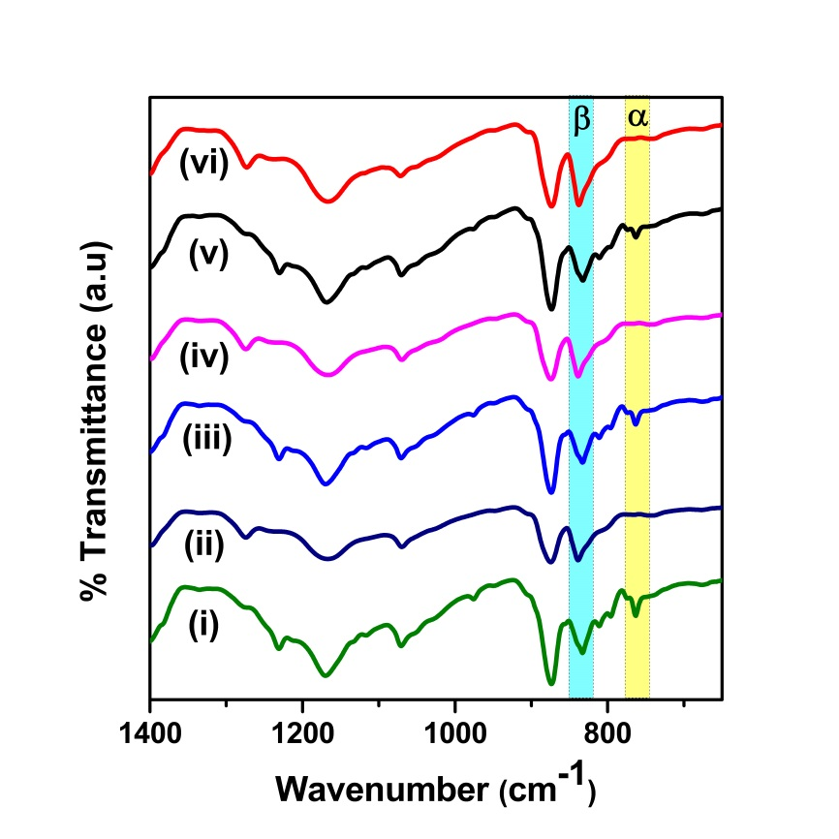
Figure S1: FT-IR spectra of PVDF composites of (i) 0.5 wt% MWCNT as pressed, (ii) 0.5 wt% MWCNT rolled, (iii) 1 wt% MWCNT as pressed, (iv) 1 wt% MWCNT rolled, (v) 2 wt% MWCNT as pressed and (vi) 2 wt% MWCNT rolled

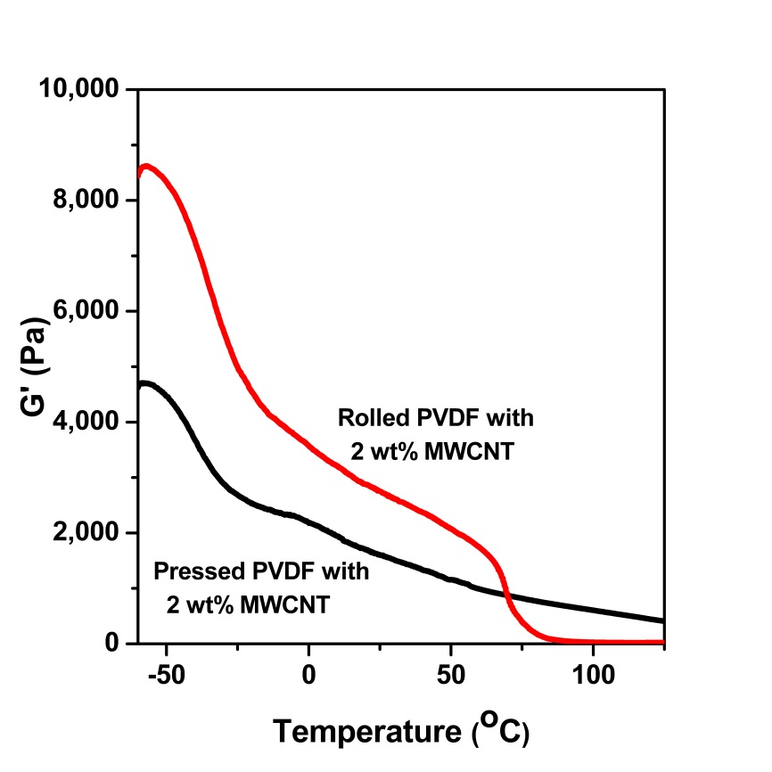
Figure S2: DMTA of as pressed and rolled PVDF with 2 wt% MWCNT
Table S1: Power law fitting exponent values of PVDF composites (obtained from AC conductivity plots)
Compositions | n
0.5 wt% MWCNT as pressed  1 wt% MWCNT as pressed  2 wt% MWCNT as pressed  0.5 wt% MWCNT rolled  1 wt% MWCNT rolled  2 wt% MWCNT rolled | 0.82  0.76  0.73  0.69  0.65  0.58

Table S2: FT-IR analysis of the variation of β-phase with concentration of MWCNTs before and after rolling.
Samples | As pressed (F_{β}) content (%) | Rolled (F_{β}) content (%)
PVDF + 0.5 wt% MWCNTs | 65 | 87
PVDF + 1 wt% MWCNTs | 66 | 88
PVDF + 2 wt% MWCNTs | 66 | 88

