Supplementary Information

On the effect of Re addition on microstructural evolution of a CoNi-based superalloy
P. Pandey^{1*}, A. K. Sawant¹, B. Nithin¹, Z. Peng², S. K. Makineni^{1,2*}, B. Gault², K. Chattopadhyay^{1*}
¹Department of Materials Engineering, Indian Institute of Science, Bangalore 560012, India.
²Department of Microstructure Physics and Alloy Design, Max-Planck-Institute für Eisenforschung, 40237 Düsseldorf, Germany
*Corresponding Authors: prafull1011@gmail.com (PP), sk.makineni@mpie.de (SKM), kamanio@iisc.ac.in (KC)

Figure S1: The proximity histogram plot showing composition profiles across the γ/γ′ interface for Co and Ni for the Co-30Ni-10Al-5Mo-2Nb-2Re (2Nb2Re) alloy subjected to aging at 900 °C for 50 hours.

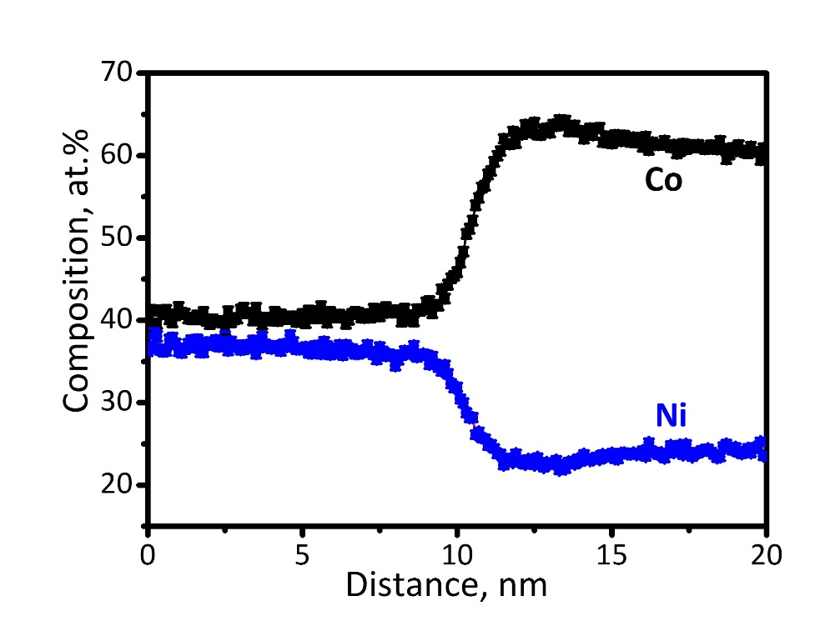
γ
γ′

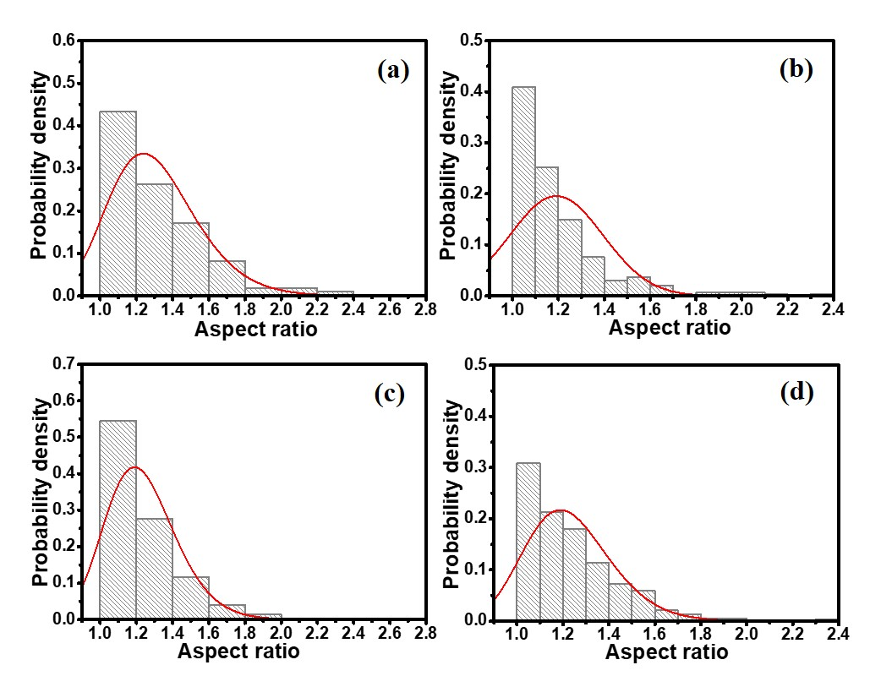
Figure S2: Change in the probability distribution function (PDF) of aspect ratios ($= \frac{diameter of largest circle}{diameter of smaller circle}$) of the γ′ precipitates in the 2Nb2Re alloy subjected to aging at 900 °C: (a) 50 h, (b) 200h, (c) 500h and (d) 1000 h.

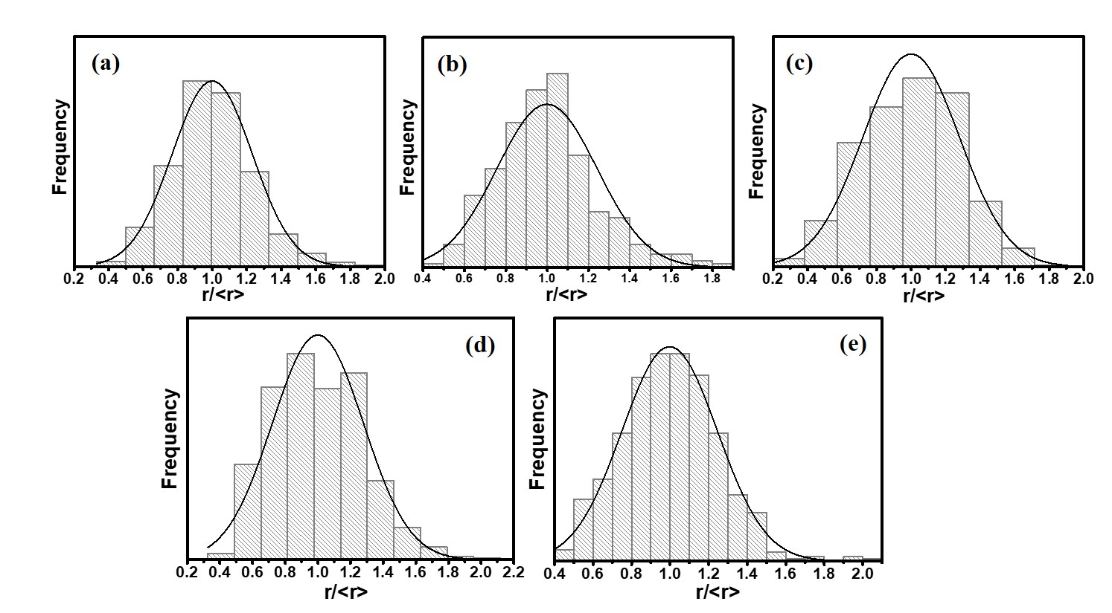
Figure S3: Change in the precipitate size distribution (PSD) as a function of the normalized precipitate size (r/<r>) of the γ′ precipitates in the 2Nb2Re alloy subjected to aging at 900 °C: (a) 50 h, (b) 200h, (c) 300h, (d) 500h and (e) 1000h. The normal distribution of precipitate size distribution is superimposed.

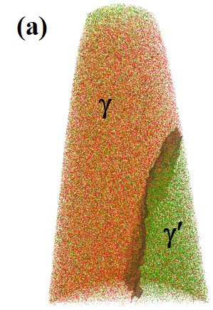
Figure S4: 3D-APT reconstruction for 2Nb2Re alloy aged at 900 C° for (a) 200 h (b) 500h and (c) 1000h, delineated by 46 at.% Co isoconcentration surface showing a partial γ′ precipitate and γ matrix and corresponding proximity histograms of the solute species Al, Mo, Nb and Re on both sides of the γ/γ′ interface. The zero position in the plot corresponds to the 46 at. % Co.
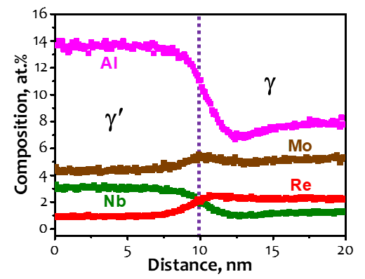

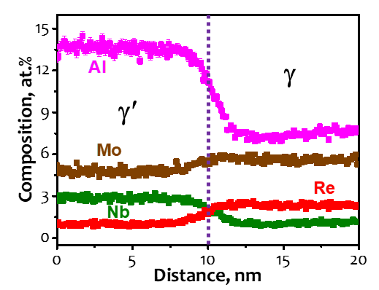
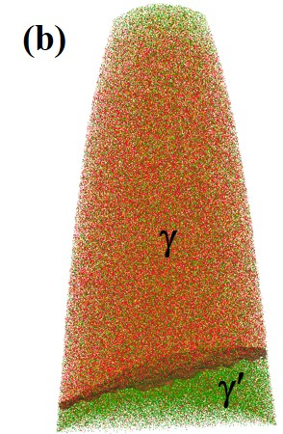

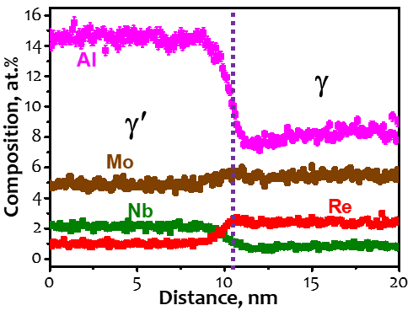
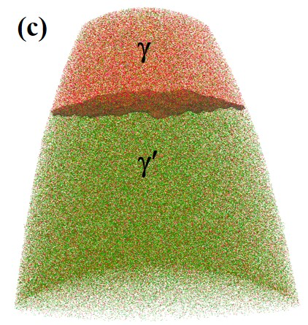

Figure S5: The composition profiles across the γ/γ′ interface for Re and Mo obtained for 2Nb2Re alloy after aging at 900 °C for (a) 200 hours, (b) 500 hours and (c) 1000 hours.

